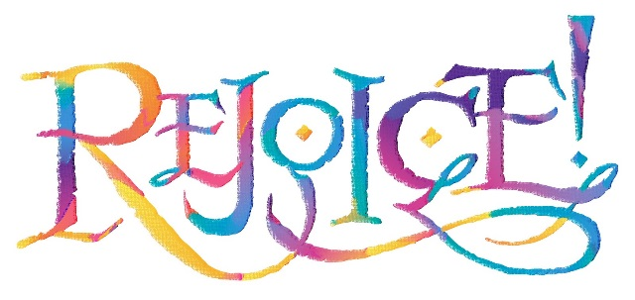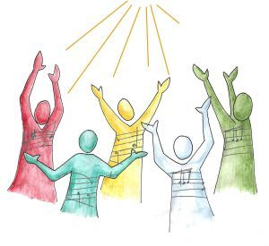

***We rejoice with the great cloud of witnesses (Heaven’s Multitudes of God’s prophets, priests, and saints) in that the God of the Universe is going on the offense against the evil empire of Satan. Hallelujah to God the Father and to His Son, Jesus, the Messiah.***

***Revelation 19:1-10, “After this I heard what sounded like the roar of a great multitude in heaven shouting: “Hallelujah! Salvation and glory and power belong to our God, 2for true and just are his judgments. He has condemned the great prostitute who corrupted the earth by her adulteries. He has avenged on her the blood of his servants.” 3And again they shouted: “Hallelujah! The smoke from her goes up for ever and ever.” 4The twenty-four elders and the four living creatures fell down and worshiped God, who was seated on the throne. And they cried: “Amen, Hallelujah!” 5Then a voice came from the throne, saying: “Praise our God, all you his servants, you who fear him, both great and small!” 6Then I heard what sounded like a great multitude, like the roar of rushing waters and like loud peals of thunder, shouting: “Hallelujah! For our Lord God Almighty reigns. 7Let us rejoice and be glad and give him glory! For the wedding of the Lamb has come, and his bride has made herself ready. 8Fine linen, bright and clean, was given her to wear.” 9Then the angel said to me, “Write this: Blessed are those who are invited to the wedding supper of the Lamb!” And he added, “These are the true words of God.” 10At this I fell at his feet to worship him. But he said to me, “Don’t do that! I am a fellow servant with you and with your brothers and sisters who hold to the testimony of Jesus. Worship God! For it is the Spirit of prophecy who bears testimony to Jesus.”***

***Worship is the Vehicle that Brings “Us” into God’s Presence.***

***Who is/are “us”?***

***Do you enjoy worshiping and praising the Lord?***

***If you don’t, you are a sick Christian…that is, if you are a Christian!***

***Some of the most blessed quotations on praise are:***

*“Praise Douses Doubts and Waters Faith at the Same Time.”*

*“Praise Crowns Obedience and Puts the Praiser Over into the Victory Column.”*

*“While Praise is the Highest of Spiritual Exercise it is Something We Become Before it is Something We Do.”*

*“Our Lives First Become Songs of Praise….Then Out of Our Lives Issue Meaningful Songs of Praise.”*

*“Praise is a Decisive Down-Payment on and Plays the Greatest Role in Mental Health and Emotional Stability.”*

*“Praise, Like a Straight Line, is the Shortest Distance between a Saint and His God!”*

***Note: I have no idea who were the ones that made the statements on praise; but, they are worthy of repeating***

***Bowing before Him in Worship is our greatest expression of Reverence, Awe, and Humility.***

***Remember, Praise and Worship are not a means to manipulate God into Blessing us….Our Goal is to Bless Him and Have a Meaningful Relationship with Him…..***

***The Blessing comes as a Result.***

***Worship Does Not Bring Miracles….GOD Does!!***

***Worship and Praise Do Not Bring Healing….God Does!***

***Jesus is the “I AM” and the “Amen” of Creation.***

***He is the “First and the Last.”***

***In 1 Chronicles 16:36, the people responded to great praises with “Amen and Praise the Lord!”***

***Here we see the multitudes in heaven, as well as the 24 elders, stating the same thing…..Hallelujah and Amen!***

***“Amen” is a word of praise.***

* ***Found more than 25 times in the Old Testament…..More than 125 times in the New Testament.***
* ***It means “Sure, Steadfast, and Permanent.”***
* ***It is translated many times in the New Testament as:***

***“Verily, verily” or “Truly, truly” and beacons unlimited belief.***

* ***It is a*** ***word of agreement….agreement between man and his God.***

***It is a word of finality…..It is a word of Authority and Agreement!***

**The Wedding of the Lamb—**

**The Lamb and His bride (the spotless church) will be married. The spotless church will make herself ready by “being purified by the Blood of Jesus.”**

**This is “those (you and me) who have been washed in the blood of Jesus (the Lamb).”**

**Who will be at the Wedding? Yes, the Church—All people (every race, gender, person) who has done what it says in Romans 10:9, “If you will confess with your mouth the Lord Jesus, and believe in your heart that God has raised Him from the dead, you will be saved.” Those who have been redeemed by the blood of the Lamb.**

**But…We will not be invited! The bridegroom and the bride are never invited to their own wedding!!**

**Who will be invited as guests?**

**Friends of the Bridegroom…**

1. **John the Baptist_---the friend of the bridegroom (John 3:29, “…the friend of the Bridegroom.”**
2. **Old Testament Saints from Adam to the “Church Age”…their faith has provided the reason for the invitation.**

**John falls at the feet of the Messenger (angel) who forbids it.**

**We are not to worship anyone or anything …Nobody…but the Lord God Jehovah.**

**Angels are not to be worshipped.**

Today’s society uses angels…and even sells angel paraphernalia to proclaim angels as being very reverent and highly favored for either worship or held in high esteem. Not all angels are reverent or even on God’s side….some are part of the scheme of the head angel who rebelled against God…Satan. They are Satan’s workers of iniquity.

**What and who tells us that angels are not to be worshipped?**

**Answer: Our passage today with a testimony of the 2nd witness:**

1. **Revelation 19:9-10, “Then the angel said to me, ‘Write: Blessed are those who are invited to the wedding supper of the Lamb! And he added, ‘These are the true words of God.’ At this I fell at his feet to worship him, But he said to me, 'Do not do it! I am a fellow servant with you and with your brothers who hold to the testimony of Jesus. Worship God! For the testimony of Jesus is the spirit of prophecy.”**
2. **Revelation 22:8-9 “I, John, am the one who heard these things. And when I had heard and seen them, I fell down to worship at the feet of the angel who had been showing them to me. But he said to me, “No, don’t do anything like that! I am a fellow servant with you and with your brothers the prophets and of all who keep the words of this book. Worship God alone!”**

We are not to worship anyone except the God head….not angels, not Mary, nor saints. Worship God the Father, God the Son, and God the Holy Spirit of the Living God... alone.

When someone is baptized…Protestants and Catholics, the words are said (and rightly so).

“In the name of the Father, the Son, and the Holy Spirit.”

***Postscripts on Praise!***

* *“Praise is an impenetrable defense before the enemy and an indefensible weapon in Spiritual Warfare.”*
* *“God is restoring Praise to His church and with it the graces that will make the Bride-elect both Bride-conscious and Bride-beautiful.”*
* *“Praise is the most powerful tonic for a tired soul and greatest therapy for a heavy spirit.”*
* *“Praise is the Church’s secret weapon against which the enemy has no defense and before which His ranks fall into confusion and disarray.”*

**Hallelujah!**