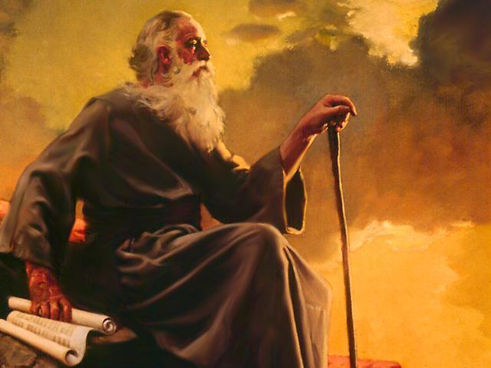 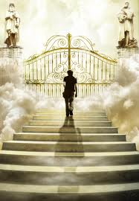

***Remember…Revelation 1:19, “Write, therefore, what you have seen, what is now and what will take place later.”***

***We are now going to study the prophecy of Revelation as John listened and adequately wrote with perfect integrity in the perfect will of God.***

***Revelation 4:1*, *“****After this I looked, and there before me was a door standing open in heaven. And the voice I had first heard speaking to me like a trumpet said, “Come up here, and I will show you what must take place after this.”*

***The Door to Heaven as John Saw It----***

***2 Possibilities:***

1. ***John thought he was already in heaven, and a door is opening into still more Holy parts of heaven.***
2. ***Door from EARTH to HEAVEN.***

***Three (3) Important Doors of Life in Revelation:***

1. ***Door of OPPORTUNITY Rev. 3:8***
2. ***Door of the HUMAN HEART Rev. 3:20***
3. ***Door of REVELATION Rev. 4:1***

***All three doors are offered to man---There are no LOCKS.***

***Only you can place the lock on the door! By your refusal to let the Lord Jesus in, you prevent His entrance. He seeks, He knocks, He doesn’t turn away; you turn from Him.***

#### ***May God, through His Spirit, quicken our hearts to accept His invitation.

##### The Throne of God—Revelation 4:2-3, “At once I was in the Spirit, and there before me was a throne in heaven with someone sitting on it. 3And the one who sat there had the appearance of jasper and ruby. A rainbow that shone like an emerald encircled the throne.”

***Common Old Testament picture “God sitting on the throne.”***

***1 Kings 22:19; Psalm 47:8; Isaiah 6:1***

***God---Not in any HUMAN form. He was in the form of Radiant light.***

1. ***Three (3) Precious Stones***
2. ***Jasper—Stands for PURITY of God.***
3. ***Sardian—Stands for God’s AVENGING WRATH (JUSTICE).***
4. ***Emerald—Stands for God’s MERCY.***

***God’s Mercy is the only way we can stand in the presence of the God of PURITY and JUSTICE.***

**Revelation 4:4-11**, *“Surrounding the throne were twenty-four other thrones, and seated on them were twenty-four elders. They were dressed in white and had crowns of gold on their heads. 5From the throne came flashes of lightning, rumblings and peals of thunder. In front of the throne, seven lamps were blazing. These are the seven spiritsof God. 6Also in front of the throne there was what looked like a sea of glass, clear as crystal. In the center, around the throne, were four living creatures, and they were covered with eyes, in front and in back. 7The first living creature was like a lion, the second was like an ox, the third had a face like a man, the fourth was like a flying eagle. 8Each of the four living creatures had six wings and was covered with eyes all around, even under its wings. Day and night they never stop saying: “‘Holy, holy, holy is the Lord God Almighty,’ who was, and is, and is to come.” 9Whenever the living creatures give glory, honor and thanks to him who sits on the throne and who lives for ever and ever, 10the twenty-four elders fall down before him who sits on the throne and worship him who lives for ever and ever.* They lay their crowns before the throne and say: “You are worthy, our Lord and God, to receive glory and honor and power, for you created all things, and by your will they were created and have their being.”

#### Facts about the 24 Elders

1. ***They sit around the throne, clothed in white and wearing crowns***
2. ***They cast their crowns before the throne***
3. ***They continually worship and praise***
4. ***They bring to God the prayers of the saints (5:8)***
5. ***They encourage (5:5)***

# Explanation of the 24 Elders

***(Possible Meanings)***

1. ***A council surrounding God (1 Kings 22:19)***
2. ***Priests in Israel (1 Chronicles 24:7-18)***
3. ***Stand for 12 Patriarchs and the 12 apostles combined***

***(Revelation 21:12-14)***

1. ***Symbolic representatives of the faithful people of God***

***(Revelation 3:4)***

1. ***Stand for the church in its totality (Jews and Gentiles).***

# Around the Throne, Revelation 4:5,6a

1. ***Thunder and Lightning are often connected with the manifestation of God.***
2. ***Seven Torches are the seven spirits of God.***
3. ***Like a “Sea of Glass”---Shining glass symbolizes preciousness and dazzling purity.***

### The Four Living Creatures, Revelation 6b-9

**They symbolize:**

1. ***Clearly part of the imagery of heaven***
2. ***Stand for everything that is noblest, strongest, wisest, and swiftness in nature.***
3. ***Nature/God’s creation—literally everything praising God (Psalm 148 and Psalm 150:6)***

***Four living creatures represented 4 aspects of the work of Jesus Christ (some scholars teach):***

1. ***Lion—symbolizes the powerful and effective working of the Son of God, His leadership and His royal power.***
2. ***Ox—­­­­­­­­­­­­­­­­­­­symbolizes the priestly side of His work (sacrifice).***
3. ***Man—symbolizes His incarnation (union of divinity and humanity).***
4. ***Eagle—Represents the gift of the Holy Spirit.***

# The Elders Cast Their Crowns before the Throne of God, Revelation 4:10

1. ***Sign of complete submission***
2. ***There can be no Christianity without total submission.***

##### The Song of Praise, Revelation 4:6b-8

***Night and day the living creatures never rested from their doxology of praise.***

***“Holy, holy, holy is the Lord, the Almighty, who was, and who is, and who is to come.” THIS IS A REPEAT OF REVELATION 1:8***

***The Doxology seizes on three (3) aspects of God:***

1. ***It praises Him for His Holiness,***
2. ***It praises His omnipotence (God is Almighty)***

***Definition: Omnipotent = one who is unlimited in power and authority and ability.***

1. ***It praises His everlastingness…God lasts forever.***

***Empires might go…but, God will stand FOREVER!***

** Praise God, from Whom all blessings flow; Praise Him, all creatures here below; Praise Him above, ye heavenly host; Praise Father, Son, and Holy Ghost. Hallelujah!**

