

“He that hath an ear let him hear what the spirit says to the churches.”

The final statement to each of the seven churches.

***Listen…friend…listen closely!***

“To whom can I speak and give warning? Who will listen to me? Their ears are closed so they cannot hear. The word of the Lord is offensive to them; they find no pleasure in it.” Jeremiah 6:10

*“Son of man, you are living among a rebellious people. They have eyes to see but do not see…and ears to hear but do not hear, for they are a rebellious people.” Ezekiel 12:2*

*“But they refused to pay attention; stubbornly they turned their backs and stopped up their ears.” Zechariah 7:11*

*“They will turn their ears away from the truth and turn aside to myths.” 2 Timothy 4:4*

***Remember….If God wanted you to talk more than listen, He would have given you 2 mouths and 1 ear.***

***For…Wisdom comes from your eyes, your ears and your heart!***

***Children’s song: Be careful little eyes what you…Be careful ears what you hear. For the Father up above is looking down in love; oh, be careful little ears what you hear.***

*“He who listens to a life-giving rebuke will be at home among the wise.” Proverbs 15:31*

*“Blessed is the man who listens to me, watching daily at my doors, waiting at my doorway.” Proverbs 8:34*

*“Guard your steps when you go to the house of God. Go near to listen rather than to offer the sacrifice of fools, who do not know that they do wrong.” Ecclesiastes 5:1*

***Revelation 2:18-29,*** *“To the angel of the church in Thyatira write: These are the words of the Son of God, whose eyes are like blazing fire and whose feet are like burnished bronze.  I know your deeds, your love and faith, your service and perseverance, and that you are now doing more than you did at first. Nevertheless, I have this against you: You tolerate that woman Jezebel, who calls herself a prophet. By her teaching she misleads my servants into sexual immorality and the eating of food sacrificed to idols. I have given her time to repent of her immorality, but she is unwilling. So I will cast her on a bed of suffering, and I will make those who commit adultery with her suffer intensely, unless they repent of her ways. I will strike her children dead. Then all the churches will know that I am he who searches hearts and minds, and I will repay each of you according to your deeds. Now I say to the rest of you in Thyatira, to you who do not hold to her teaching and have not learned Satan’s so-called deep secrets, ‘I will not impose any other burden on you, 25except to hold on to what you have until I come.’ To the one who is victorious and does my will to the end, I will give authority over the nations— that one ‘will rule them with an iron scepter and will dash them to pieces like pottery’—just as I have received authority from my Father. I will also give that one the morning star. Whoever has ears, let them hear what the Spirit says to the churches.”*

***What Do You Consider the # 1 Problem in the World Today?***

### Church at Thyatira…had a problem!

***Their problem was no different than problems in the United States today….nor Texas….nor Burleson or Ft. Worth!***

***Actually...the Church at Thyatira was having similar problems as to what churches are having in the world today…..The big word…the big problem….***

# Compromise

In this lesson and the next, we are going to try and answer or give some ideas as to what might have been the situation in the Church at Thyatira…their problems….Who was Jezebel? What did she teach? What do the promises made to the Church at Thyatira mean!

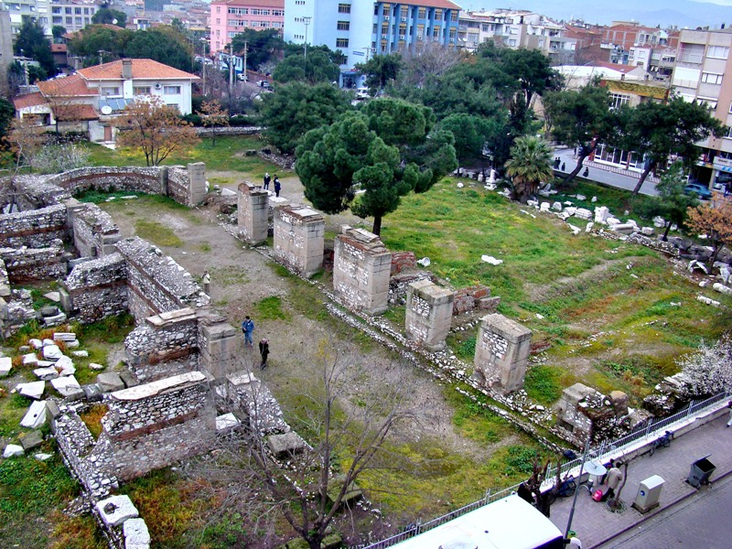

***City of Thyatira...***

* ***Least important of the seven (7) cities***
* ***Geographically important….lies on the road from Sardis to Pergamum…Gateway to Pergamum (the capital of Asia)***
* ***Armed garrison there (Roman)…actually to protect from intruders heading toward the capital.***
* ***Lay in an open valley…No protection.***
* ***No special religious significance…Only notable religious cult was a fortune-telling group who had a shrine…presided over by a female oracle called “the Sambathe.”***
* ***Less known about Thyatira than all the other cities.***

***Today, the city is called AK Nissar---meaning “White Castle”***

***Known for scarlet cloth***

***Present population of 15-20,000***

***Nine (9) Mosques in AK Nissar….***

***Very few Christians…most are worshipping secretly for fear of being persecuted verbally and physically.***

***An Overcomer….Washed in the Blood of the Lamb.***

***1 John 5:1; 4-5, “Everyone who believes that Jesus is the Christ is born of God, and everyone who loves the Father loves His child as well (the children of God)……..for everyone born of God overcomes the world. This is the victory that has overcome the world, even our faith. Who is it that overcomes the world? Only he who believes that Jesus is the Son of God.”***

*Revelation 12:11, “They overcame him (the accuser) by the blood of the Lamb and by the word of their testimony.”*

*1 Corinthians 3:12-15, “If any man builds on this foundation using gold, silver, costly stones, wood, hay or straw, his work will be shown for what it is, because the Day will bring it to light. It will be revealed with fire, and the fire will test the quality of each man’s work. If what he has built survives, he will receive his reward. If it is burned up, he will suffer loss; he himself will be saved, but only as one escaping through the flames.”*

*Revelation 20:12-15, “And I saw the dead, great and small, standing before the throne, and books were opened. Another book was opened, which is the book of life. The dead were judged according to what they had done as recorded in the books. The sea gave up the dead that were in it, and death and Hell gave up the dead that were in them, and each person was judged according to what he had done. Then death and Hell were thrown into the lake of fire. The lake of fire is the second death. If anyone’s name was not found written in the book of life, he was thrown into the lake of fire.”*

*2 Peter 3:9, “The Lord is not slow in keeping His promise, as some understand slowness. He is patient with you, not wanting anyone to perish, but everyone to come to repentance.”*

***We have the victory….we have overcome the world!***

***Revelation 21:7….He saves the best for last***

***“He who overcomes will inherit all this, and I will be his God and he will be my son.”***

## Thyatira was a great commercial center

* *Makers of outer garments, dyers, potters, bakers, and slave traders….Lydia, seller of purple, lived there.*
* *Lots of guilds …”Association for Mutual Profit and Pleasure.”*

*To refuse to join a trade guild, was much like a trucker not joining the Teamster’s Union*

* *Refusing meant giving up all prospect of commercial existence (difficult to make any kind of living in your trade or profession).*

## Why should a Christian not join one of these guilds?

* *They held common meals…that were often held in the temple. Begin and end with a formal sacrifice to the gods…the meat eaten would be that which had been offered up to the gods.*
* *Meals were actually drunken revelry and loose morality (sexual pleasures explored).*
* *Was it possible for a Christian to be a part of such occasions?*

### Church at Thyatira…

* ***On the surface, the church was strong and flourishing***
* ***Church with a lot of energy, generous liberality, and apparent steadfastness***
* ***Something missing…Church was a Christian Club rather than a Christian congregation***
* ***A church with a lot of energy…flourishing with a lot of people….but, this type of church might not be a “real church”***
* ***It could be that the people are coming to be entertained instead of instructed; soothed instead of confronted with sin.***

**Description of Christ…The Risen Christ**

The Son of God comes on the scene with somewhat of a threat in the description.

**“Eyes like a flame of fire and feet like burnished bronze.”**

*Description taken from Daniel 10:6, “His face was like the appearance of lightening, and his eyes like flaming torches, his arms and legs like the gleam of burnished bronze****.”***

**Flaming eyes stands for two (2) things:**

1. **Blazing anger against sin.**
2. **Awful penetration of the gaze, which strips the disguises away and sees into a man’s inmost heart.**

**Commendation for the church:**

**I know your works:**

**Your love, your loyalty, your service, your steadfast endurance…**

**And…you are growing in the faith (Christ). You love me more now than you did at first.**

**Condemnation of the church:**

You are not dealing with that woman Jezebel and making any effort to thwart, stop her teaching my servants from doing her wickedness.

She is “seducing” the servants of God to commit fornication and eat meat offered to idols.

**Jezebel in the Old Testament:**

1. Reputation for wickedness
2. Wife of Ahab: Daughter of King of Sidon.
3. She brought in other gods from Sidon and caused Ahab and his people to worship Baal.
4. She didn’t necessarily want to banish the worship of Jehovah, if the prophets of Jehovah would accept Baal in addition to Jehovah.
5. She eventually killed (or had killed) the prophets of the Lord.
6. Ahab’s evil genius
7. She left behind her a name of “harlotries and sorceries” (2 Kings 9:22).

# “Jezebel” in the Church at Thyatira

She was an evil influence in the life and worship of the Christian church.

NOTE: SHE DIDN’T WANT TO DESTROY THE CHURCH…BUT BRING IN NEW WAYS WHICH EVENTUALLY WOULD DESTROY THE FAITH.

### What about this woman Jezebel ….in the Church at Thyatira?

***Jezebel…Probably not the woman’s name…but, was considered a Jezebel…***

**She was accused of teaching 2 things:**

1. ***Eating meat offered to idols***
2. ***Committing fornication.***

***Guilty of the same sin that Eve was:***

***Rebellion and disrespect for authority***

***Definition:***

* ***Idolatry = excessive reverence or devotion to some person or thing.***
* ***Fornication = (Webster)***

1. ***Any unlawful sexual encounter, including adultery.***
2. ***Worship of Idols***

***She was an evil influence on the life and worship of the Christian Church:***

* ***Eating meat offered to idols….urged the Christians to join the Trade Guilds and realize that “a little pleasure never hurt anyone.”***
* ***She taught that it was just as important to be successful commercially and politically as it was to claiming that Jesus Christ is Lord of all.***
* ***Fornication can mean 2 things (Biblically speaking):***

1. ***Sexual Immorality***
2. ***Spiritual Infidelity***

***Spiritual infidelity….Infidelity to God is expressed in terms of fornication and adultery***

* ***Old Testament: Israel…Bride of God (Isaiah and Jeremiah) “Israelites “played the harlot after strange gods.”…Exodus 34:15,16; Deut. 31:16; Hosea 9:1***
* ***New Testament: Church…Bride of Christ (2 Corinthians and Ephesians) “Evil and adulterous generation.” Matthew and Mark***

***If this is the kind of fornication the lady was leading some into, her followers (lovers) were those listening to her teaching, flirting with her ideas…and her children were those who had accepted it!***

***I.e. Mormanism and other cults***

***Today’s Seduction (Right Now)… Christlim***

***Teaching Sexual Immorality…***

***Liberalism always sinks to the lowest ebb…***

***“The depths of Satan”***

* ***Adultery…Sexual favors amongst us***
* ***Homosexuality…Free choice…***

Liberalism Always tears down our morals.

* ***“Free thinking” culminates in a “free lifestyle.”***
* ***“Doing your own thing”***

***“Nobody has the right to tell you what to do”***

***Remember….It is alright to do as you please….so long as you please to do right!***

PROMISE TO THOSE THAT OVERCOME AND KEEPS THE WORD OF THE LORD TO THE END:

* **The Nations shall be your heritage.**

***Psalm 2:8, “The missionary promise.”***

* **Morning Star**
  + ***Promise of the first resurrection***

***As the morning star rises after the night, the Christian will rise after the night of death.***

* ***Promise of Complete power over sin and Lucifer. Sin is darkness and the Christian will see the dawning light by seeing the Morning Star.***
* ***Daniel 12:3…The morning star is the glory which will come to those who are righteous.***
* ***The promise of the morning star is Jesus Christ himself.***

***Rev. 22:16, “Jesus is the bright and morning star.”***

***“LET HIM WHO HEARS LISTEN TO WHAT THE SPIRIT IS SAYING TO THE CHURCHES.”***

***LISTEN, MY CHILDREN, LISTEN….I AM COMING SOON!!***

