***The Holy Spirit In Us and With Us!***

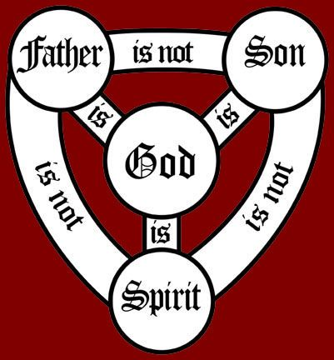

***PARTNERSHIP: a relationship resembling a legal partnership and usually involving close cooperation between*** [***parties***](https://www.merriam-webster.com/dictionary/parties) ***having specified and joint rights and responsibilities.***

***TRINITY = The God Head—One in Three… They each have a specific purpose in the final plan to achieve a successful transition of God’s children from earth to heaven.***

***OUR SALVATION: God planned it; Jesus provided it; the Holy Spirit prompts it through conviction and convincing.***

***The Holy Spirit…according to John, helps us to understand that the Spirit of God dwells in us. (Holy Spirit is the liaison between God and man).***

*1 John 3:24b, “…and this is how we know that He lives in us; we know it by the Spirit he gave us.”*

***Romans 8:9,*** *“You, however, are not in the realm of the flesh but are in the realm of the Spirit, if indeed the Spirit of God lives in you. And if anyone does not have the Spirit of Christ, they do not belong to Christ.”*

***John 14—16***

1. ***Reveals that Jesus and the Father are actually One in spirit. Jesus’ works and acts are to glorify the Father.***
2. ***Reveals that The Holy Spirit was sent to us to glorify the Son.***

***ALL THE MIRACLES, ACTS, WORKS BY THE SPIRIT ARE TO GIVE US A TASTE OF WHO WE ARE IN CHRIST JESUS.***

***Our Commission….The command “….be filled with the Spirit”***

***(Ephesians 5:18-20, “****Do not get drunk on wine, which leads to debauchery.* ***Instead, be filled with the Spirit****, 19speaking to one another with psalms, hymns, and songs from the Spirit. Sing and make music from your heart to the Lord, 20always giving thanks to God the Father for everything, in the name of our Lord Jesus Christ.****”***

***Note: It is capital “S” (Spirit) i.e. Holy Spirit; not just a spirit of thanks, not just songs with spirit; but, from the Holy Spirit.***

***When the Holy Spirit possesses our spirit, we have a joyful spirit, a zealous and aggressive (not passive) spirit…one that makes us effective servants of Christ.***

***As the Holy Spirit lives in us, we have to understand that:***

***THE HOLY SPIRIT IS WITH US!***

*John 14:15-18, “If you love me, keep my commands. 16And I will ask the Father, and* ***he will give you another advocate to help you and be with you forever— 17the Spirit of truth. The world cannot accept him, because*** *it neither sees him nor knows him. But you know him, for* ***he lives with you and will be in you. 1****8I will not leave you as orphans; I will come to you.”*

***Life in the Spirit is a blessing and should never be taken for granted.***

***Keeping His commandments is a qualifying condition for the Holy Spirit living with us.*** *Oh, yes…we will fail; but, we will have an advocate to help us back to the truth.*

***Obedience is the key to your peace and contentment as to knowing the Holy Spirit is at your side/in and with you.***

***When we receive the Holy Spirit, we have an advocate.***

***What does this mean to you…WE HAVE AN ADVOCATE?***

***Having the Holy Spirit living in us and with us, we are:***

***ENERGIZED WITH POWER! The Holy Spirit brings hope, power, and confidence in the middle of uncertainty.***

***God speaks through the Holy Spirit by the revelation of His Word. He gives us thoughts, suggestions, impressions, or notions. This is to enlighten us with inspiration to seek the truth.***

***The Holy Spirit reminds us of God’s truth to give us power to overcome the circumstances which are trying to hinder our spiritual activities.***

*John 14:26, “But the Advocate, the Holy Spirit, whom the Father will send in my name, will teach you all things and will remind you of everything I have said to you.”*

***The Holy Spirit is our Teacher and Counselor. He’s like a personal Coach!***

***THE HOLY SPIRIT ENRICHES US WITH LOVE***

***Love is a sign of trust; Fear is a sign of doubt.***

***Do you think love has lost its distinction and true definition in today’s culture? Affection = takes delight in affirming others. Friendship = deeply felt togetherness; a sense of joy when with each other. Eros = Gk. A romantic, passionate kind of love; a love between lovers. Agape = the highest form of love; unconditional love; seeking the highest good for the other person.***

***Agape love finds its fullest expression in God’s love toward us. He desires us that we love each other with that same agape love.***

* ***Love unites rather than divides us.***
* ***Love is always patient with others progress.***

***THE HOLY SPIRIT ENLIGHTENS US WITH A PROPER PERSPECTIVE***

* ***The Holy Spirit helps our perspective because His job is to magnify and glorify Jesus.***
* ***Perspective influences our actions, shapes our thinking, and ultimately impacts our lives.***

***As we welcome the fullness of the Holy Spirit in our lives, He will energize us with power when we feel we have no strength left (Psalm 46:1), He will enrich us with love when it seems everyone around us is aggravating and annoying us (1 John 3:18-20), and He will enlighten us with a proper perspective on life (Isaiah 41:10).***