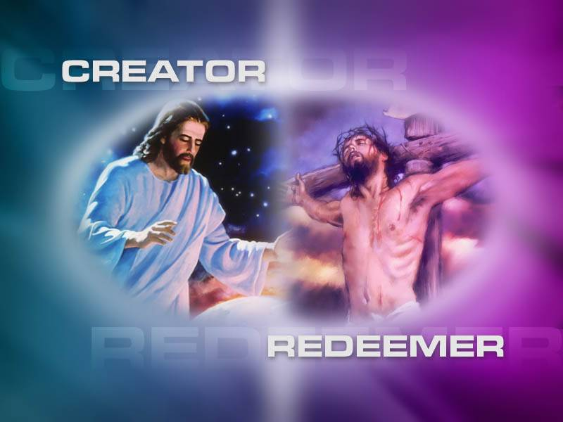

***Lesson #3, The Superiority of Christ—Better Than the Best***

***Someone said, “Tom Brady is a superior, premier…one of kind quarterback.”***

***What would one be saying if he made that statement?***

***The Superiority of Christ…***

* ***The relationship of Christianity to Judaism was a critical issue in the early church.***
* ***The author clears up confusion by carefully explaining how Christ is superior to angels, Moses, and high priests.***
* ***The new covenant is shown to be far superior to the old.***

***This can be of great encouragement to us and help us avoid drifting away from our faith in Christ.***

***Hebrews 1:1-2:1,*** *In the past God spoke to our ancestors through the prophets at many times and in various ways, 2but in these last days he has spoken to us by his Son, whom he appointed heir of all things, and through whom also he made the universe. 3The Son is the radiance of God’s glory and the exact representation of his being, sustaining all things by his powerful word. After he had provided purification for sins, he sat down at the right hand of the Majesty in heaven. 4So he became as much superior to the angels as the name he has inherited is superior to theirs. 5For to which of the angels did God ever say, “You are my Son; today I have become your Father”? Or again, “I will be his Father, and he will be my Son”? 6And again, when God brings his firstborn into the world, he says, “Let all God’s angels worship him.” 7In speaking of the angels he says, “He makes his angels spirits, and his servants flames of fire.” 8But about the Son he says, “Your throne, O God, will last for ever and ever; a scepter of justice will be the scepter of your kingdom. 9You have loved righteousness and hated wickedness; therefore God, your God, has set you above your companions by anointing you with the oil of joy.” 10He also says, “In the beginning, Lord, you laid the foundations of the earth, and the heavens are the work of your hands. 11They will perish, but you remain; they will all wear out like a garment. 12You will roll them up like a robe; like a garment they will be changed. But you remain the same, and your years will never end.” 13To which of the angels did God ever say, “Sit at my right hand until I make your enemies a footstool for your feet”? 14Are not all angels ministering spirits sent to serve those who will inherit salvation? 2:1, We must pay the most careful attention, therefore, to what we have heard, so that we do not drift away.”*

***The book describes in detail how Jesus Christ not only fulfills the promises and prophecies of the Old Testament, but how Jesus Christ is better than everything in the Jewish system of thought.***

***God used many approaches to send his messages to people in Old Testament times.***

* ***Isaiah in visions (Isaiah 6)***
* ***Jacob in a dream (Genesis 28:10-22)***
* ***Abraham and Moses personally (Genesis 18; Exodus 31:18)***

***Remember: Jewish people were very familiar with these stories…and would not have found it hard to believe that God was still revealing His will.***

***However, it was astonishing for them to think that God had revealed Himself by speaking through His Son, Jesus Christ.***

***Jesus is the fulfillment and culmination of God’s revelation through the centuries.***

***When we know Him, we have all we need to be saved from our sin and to have a perfect relationship with God.***

***MY JESUS…YOUR JESUS…IS MORE THAN ENOUGH!***

***JESUS IS NOT ONLY THE EXACT REPRESENTATION OF GOD…HE IS GOD HIMSELF.***

* ***He is eternal,***
* ***He worked with God in creating the world (John 1:3; Colossians 1:16)***
* ***He is full revelation of God.***

***THERE IS NO CLEARER VIEW OF GOD THAN BY LOOKING AT CHRIST.***

***JESUS Christ is the complete expression of God in a human body.***

***The Book of Hebrews links God’s saving power with His creative power.***

***The power that brought the universe into being and keeps it operating….is the same power that removes (provides purification for) our sins.***

* ***No sin is too big for the Ruler of the universe to handle.***
* ***He can and will forgive us when we come to Him through His Son.***

***That Jesus “SAT DOWN” means that the work was complete.***

***CHRIST’S SACRIFICE WAS FINAL.***

***V.4….Christ is greater than the angels***

***The audience of 1st century Jewish Christians had developed an imbalanced belief in angels and their role.***

***Question: Do you feel that we have many Christians that have an unhealthy view of angels today?***

***Christ and the angels:***

***Christ’s lordship is affirmed without disrespect to God’s valued angelic messengers.***

***How Christ is Superior to Angels:***

* ***Christ is called “Son” of God, a title never given to an angel (v. 5,6) O.T. Psalm 2:7***
* ***Angels are important, but are still only servants under God (1: 7, 14) O.T. Psalm 104:4***
* ***Christ’s kingdom is forever (v. 8,9….O.T. Psalm 45:6***
* ***Christ is the Creator of the world (v. 1)…O.T. Psalm 102:25***
* ***Christ is given unique honor by God. (v. 13)…O.T. Psalm 110:1***

***The writer of Hebrews quotes from the Old Testament repeatedly in demonstrating Christ’s greatness in comparison to the angels.***

***False teachers in many of the early churches taught that God could be approached only through angels.***

***Instead of worshipping God directly, followers of these heretics revered angels.***

***HEBREWS CLEARLY DENOUNCES SUCH TEACHING AS false.***

***Angels are never to be worshipped…Colossians 2:18, Revelation 19:1-10).***

***Note: We should not regard any intermediaries or authorities as greater than Christ.***

***JESUS IS GOD. HE ALONE DESERVES OUR WORSHIP.***

***Don’t ever be pulled or swayed into a belief or to believe that angels are to be worshipped, adored, bowed down to, given a special place on the level of God the Father, God the Son, or God the Holy Spirit.***

***Revelation 19:9-10, “Then the angel said to me, “Write this: Blessed are those who are invited to the wedding supper of the Lamb!” And he added, “These are the true words of God.” 10At this I fell at his feet to worship him. But he said to me, “Don’t do that! I am a fellow servant with you and with your brothers and sisters who hold to the testimony of Jesus. Worship God! For it is the Spirit of prophecy who bears testimony to Jesus.”***

***Angels are unique and are used by God for the purpose of fulfilling the plans of God.***

***Summary of Lesson #3: Does Practice Really Make Perfect?***

***Answer: Practice can improve our talents and our actions, but it can never help us achieve perfection.***

***Only the Godhead is perfect. Only Jesus is perfect in human and spiritual terms.***

***However, we can practice to be better, to be one of the best, and to be a servant of God…whom God the Father will be able to say, “Well done, my good and faithful servant.”***

***Just for good measure…We can all work with a “spirit of excellence” about us!***

***The Perfect Priest and the Perfect Sacrifice..***

Only a perfect priest and perfect sacrifice could open a way for man to have direct access to God.

***Only Christ Jesus could do just that.***

***Perfect Priest because He was both:***

* ***Perfectly Human…*** 
  + ***In His humanity, He can take us to God.***
* ***Perfectly God…***
  + ***In His Godhead, He can take God to us.***

*Angels…ministering spirits sent to serve those who will inherit salvation.*

*Jesus…provides the salvation …or provided the sacrifice for our salvation.*

***Summary of summaries: We don’t need human nor supernatural beings to bring us to God. Jesus Christ has broken the barrier down and opened a direct way for us to God.***



[This Photo](https://www.flickr.com/photos/4thglryofgod/10298074446) by Unknown Author is licensed under [CC BY-ND](https://creativecommons.org/licenses/by-nd/3.0/)