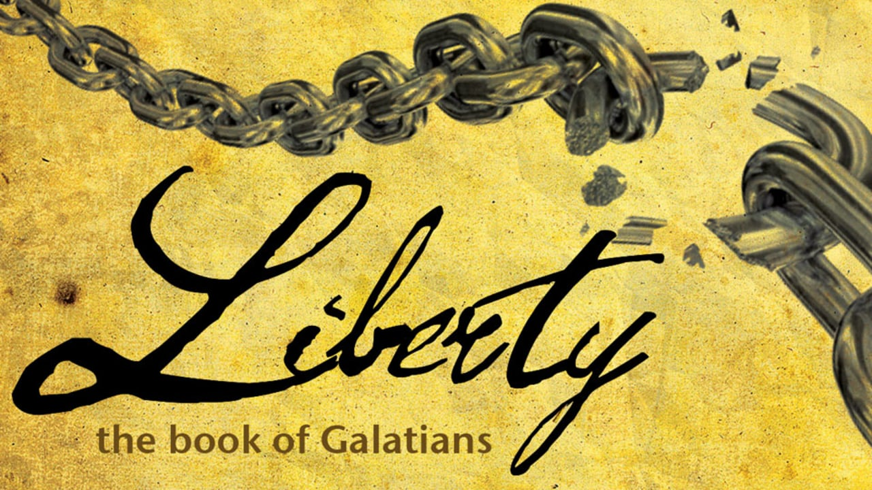

***The Law and Grace…***

[***Galatians 1:11-12***](https://www.bible-history.com/studybible/Galatians/1/) ***– “But I certify you, brethren, that the gospel which was preached of me is not after man. For I neither received it of man, neither was I taught [it], but by the revelation of Jesus Christ.”***

[***Galatians 4:4***](https://www.bible-history.com/studybible/Galatians/4/4/) ***– “But when the fullness of the time was come, God sent forth his Son, made of a woman, made under the law,…”***

[***Galatians 5:22-23***](https://www.bible-history.com/studybible/Galatians/5/) ***– “But the fruit of the Spirit is love, joy, peace, longsuffering, gentleness, goodness, faith, Meekness, temperance: against such there is no law.”***

***Galatians 2:20, “I have been crucified with Christ and I no longer live, but Christ lives in me. The life I now live in the body, I live by faith in the Son of God, who loved me and gave himself for me.”***

## ***Who wrote the book?***

***Galatians has always been among those Pauline epistles least challenged on the issue of authorship. Paul wrote to the churches in southern Galatia after having a hand in starting them on his first missionary journey to Asia Minor. Paul’s close relationship to these churches helps to explain the extremely strong tone he took with them from the very beginning of the letter. Galatians exhibits Paul at his angriest, as he risked the good favor of the converts in those churches to make sure they were on the path of truth and not led off into deception. In fact, to emphasize the seriousness of his purpose, he took the pen from his scribe and wrote the end of the letter himself in large letters (***[***Galatians 6:11***](https://biblia.com/bible/nlt/Gal%206.11)***). Chuck Swindoll***

***“The Bible is one long story of God meeting our rebellion with His rescue, our sin with His salvation, our guilt with His grace, our badness with His goodness. The overwhelming focus of the Bible is not the work of the redeemed but the work of the Redeemer. Which means that the Bible is not first a recipe for Christian living but a revelation book of Jesus who is the answer to our un-Christian living.” -Tullian Tchividjian***

**Galatians: Letter to the Churches in Galatia**



***Have you ever had someone to betray your trust?***

You might have told someone in total secrecy or have provided information about something you have done in total secrecy, but the person you entrusted the information to told one or more people about that which was private in your life?

You were devastated about knowing that there was the “supposed” friend who told others about your private conversation with her/him.

***You were BETRAYED!***

***All of us probably have had that happen to us at one or more times in your life! If you haven’t, you are in the minority!***

***What if you knew that what they said about you was slanderous? What if it would violate your trust to the point of you losing your spouse, family or close loved ones? Not only that, it also hindered your reputation among your friends including your church friends and church family.***

***Paul, God’s chosen vessel to preach to the Gentiles, had an experience like that.***

We have all misjudged someone before; thinking that you could rest your reputation on the church or friends to take your side if someone came in and tried to slander all you had taught, lived and worked for.

*Paul had spent many hours, days, and months giving his testimony…teaching and preaching the Gospel message of Christ being the Messiah. Everywhere he went, he told them about the freedom from ritualistic religious habits and works that held them under constant chains and bound them to ungodly and untruthful works to gain access to God. God gave those who believe a simple guideline to gain access to Him; belief that Jesus was the true Messiah, the Son of God, who died to set us free from the sin that keeps us from entering His presence.*

***Paul preached GRACE IN LIEU OF WORKS, FREEDOM IN LIEU OF RITUALLISTIC ACTS, AND DIRECT ACCESS TO GOD FOR FORGIVENESS OF SINS THROUGH JESUS’ BLOOD ATONEMENT GIVEN “ONCE AND FOR ALL.” “ALL” meaning all who believe and accept the plan of salvation offered to all.***

**Before we get started in Galatians, Let’s look at some important information.**

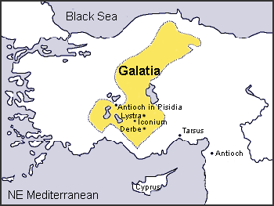

**Galatia, The Country**. (1) *Politically* it was the Roman province which included Lycaonia, Isauria, and parts of Phrygia and Pisidia. (2) Geographically it was the center of the Celtic tribes.

**The Celtic People**. They were descended from the Gauls who invaded Rome in the fourth century B. C. and in the third century B. C. invaded Asia Minor and northern Greece. A part of them remained in Galatia. The Celtic people, those that remained in Galatia, were in the mixed population formed out of the Greek, Roman and Jewish people. ***They were quick-tempered, impulsive, hospitable and fickle people. They were quick to receive impressions and equally quick to give them up. They received Paul with enthusiastic joy, and were then suddenly turned from him.***

([*Gal. 4:13-16*](https://www.studylight.org/desk/index.cgi?q1=Gal+4:13-16&t1=en_nas)*,* “*but you know that it was because of a bodily illness that I preached the gospel to you the first time; 14and that which was a trial to you in my bodily condition you did not despise or loathe, but you received me as an angel of God, as Christ Jesus Himself. 15Where then is that sense of blessing you had? For I bear you witness that, if possible, you would have plucked out your eyes and given them to me. 16So have I become your enemy by telling you the truth?).*

**The Churches of Galatia**. Just how and by whom these churches were established we do not know. The great highway from the East to Europe passed through this region, making it possible for some of those present at Pentecost to have sown the seed of the gospel there. It could have sprung up from work done by Paul while at Tarsus from the time of his return from Arabia to his going to Antioch with Barnabas. But the scripture gives us no word about this.

**Christianity in Turkey** has had a long history dating back to the 1st-century AD. The current **population** of **Turkey** is **82,582,549** as of Wednesday, February 20, 2019, based on the latest United Nations estimates. **Turkey** **population** is equivalent to 1.08% of the total world **population**.

*In modern times the percentage of Christians in Turkey has declined from 20-25 percent in 1914 to 3-5.5 percent in 1927, to 0.3-0.4% todayroughly translating to 200,000-320,000 devotees.* [*Christian denominations*](https://en.wikipedia.org/wiki/Christian_denominations)*, representing roughly 0.3-0.4 percent of Turkey's population,including an estimated 80,000* [*Oriental Orthodox*](https://en.wikipedia.org/wiki/Oriental_Orthodox)*,*[*[7]*](https://en.wikipedia.org/wiki/Christianity_in_Turkey#cite_note-Zaman-7) *35,000* [*Catholics*](https://en.wikipedia.org/wiki/Catholic_Church)*,*[*[8]*](https://en.wikipedia.org/wiki/Christianity_in_Turkey#cite_note-catho-8) *18,000* [*Antiochian Greeks*](https://en.wikipedia.org/wiki/Antiochian_Greeks)*,*[*[9]*](https://en.wikipedia.org/wiki/Christianity_in_Turkey#cite_note-9) *5,000* [*Greek Orthodox*](https://en.wikipedia.org/wiki/Greek_Orthodox_Church)[*[7]*](https://en.wikipedia.org/wiki/Christianity_in_Turkey#cite_note-Zaman-7) *and* ***8,000*** [***Protestants***](https://en.wikipedia.org/wiki/Protestantism) *= 1/100 percent of the population. It would take 100 times that many (800,000) to be equivalent of 1% of the population.*

***On the second missionary journey Paul visited the churches (***[***Acts 16:6***](https://www.studylight.org/desk/index.cgi?q1=Acts+16:6&t1=en_nas)***)*** and seems to have been taken sick while passing through and to have preached to them while unable to travel ([Gal. 4:14-15](https://www.studylight.org/desk/index.cgi?q1=Gal+4:14-15&t1=en_nas)). They gladly received his teaching, and churches seem to have sprung up.

***Paul also visited them while on the third missionary journey (***[***Acts 18:23***](https://www.studylight.org/desk/index.cgi?q1=Acts+18:23&t1=en_nas)) and instructed and established them in the faith.

The churches were running well when Paul left them, but ***Judaizing teachers*** had now come in and, acting upon their fickle and unstable nature, had greatly corrupted the simplicity of their faith.

*In the early church, those who taught a combination of God’s grace and human effort were called “Judaizers.” The word Judaizer comes from a Greek verb meaning “to live according to Jewish customs.”   
 A Judaizer taught that, in order for a Christian to truly be right with God, he must conform to the Mosaic Law. Circumcision, especially, was promoted as necessary for salvation. The doctrine of the Judaizers was a mixture of grace (through Christ) and works (through the keeping of the Law). .*

**The Reason Paul Wrote this Epistle (Galatians).**

(1) Judaizing teachers had gone among the Galatians, claiming that the Jewish law was binding upon Christians, admitting that Jesus was the Messiah, but claiming that salvation must, nevertheless, be obtained by the works of the law. They especially urged that all Gentiles be circumcised.

(2) In order to gain their point and turn the Galatians from their belief, they were trying to weaken their confidence in Paul, their spiritual teacher.

* They said he was not one of the twelve, and therefore, not one of the apostles, and his teachings were not of binding authority.
* They suggested that he had not learned his doctrine from the apostles who were pillars of the church; that he was “narcissist.”

**The Purpose of the Epistle.**

***The purpose of the epistle was:***

* To root out the errors of doctrine introduced by the Judaizers and
* To hold the Galatians to their earlier faith.
* To do this it was necessary to establish his apostolic authority and the divine origin of his gospel.
* To show the practical value or application of his teaching. He especially shows the value of Christian freedom and at the same time show that this “freedom” is not a license to keep on sinning, (playing the games that the non-believers play).

***Summary:******In fulfilling these purposes he gave us an inspired classic upon the fundamental doctrine of justification by faith and forever settled the disturbing question of the relation of Christians to the Jewish law.***

Galatians was written by Paul, probably from the city of Corinth in A.D. 57.

**Question to the class: Does God expect us to conform to God’s instructions in the Mosaic Law?**

**What laws or commandments are we to keep to be saved?**

***“Teacher, which is the greatest commandment in the Law?” 37Jesus replied: “‘Love the Lord your God with all your heart and with all your soul and with all your mind.’ 38This is the first and greatest commandment. 39And the second is like it: ‘Love your neighbor as yourself.’***