

**Foundational Series, Week 2**

**The Fall of Man**

**“Our only hope is to have a firm foundation in Christ as we live in a fallen world.”**

**A solid foundation comes from not only hearing the word of God but putting it into practice.** *James 1:22, “But don’t just listen to God’s word. You must do what it says. Otherwise, you are only fooling yourselves.”*

***Many people hear the word of God but not everyone puts it into practice. They build a good-looking house but not a sturdy one.***

***KNOW The ONE WHO CAN TAKE YOU THROUGH THE STORMS OF LIFE.***

***Storms in our lives will come in many different forms. Just because we build a solid house it doesn’t mean we won’t face storms. We build a solid foundation to withstand the storms.***

**We need to have confidence in the foundation our lives are built upon.**

**Since Adam and Eve sinned in the Garden of Eden, we have had to deal with Satan and all of his cohorts in trying to stay afloat (secure) in this fallen world. It is our destiny and responsibility to understand who we are dealing with when it comes to Satan’s cohorts. The fall of man is vividly and truthfully explained in Scripture. God reveals the fall from the beginning to the end in His Word. Therefore, read the Word, meditate on the Word, and act on the Word.**

**Scriptures on the Fall of Man:**

***Genesis 2:15-17 (NLT2),*** *“The LORD God placed the man in the Garden of Eden to tend and watch over it. 16But the LORD God warned him, “You may freely eat the fruit of every tree in the garden— 17except the tree of the knowledge of good and evil. If you eat its fruit, you are sure to die.”*

***Genesis 3:1-6 (NLT2), “****The serpent was the shrewdest of all the wild animals the LORD God had made. One day he asked the woman, “Did God really say you must not eat the fruit from any of the trees in the garden?” “Of course we may eat fruit from the trees in the garden,” the woman replied. 3“It’s only the fruit from the tree in the middle of the garden that we are not allowed to eat.” God said, ‘You must not eat it or even touch it; if you do, you will die.’” 4“You won’t die!” the serpent replied to the woman. 5“God knows that your eyes will be opened as soon as you eat it, and you will be like God, knowing both good and evil.” 6The woman was convinced. She saw that the tree was beautiful and its fruit looked delicious, and she wanted the wisdom it would give her. So she took some of the fruit and ate it. Then she gave some to her husband, who was with her, and he ate it, too.*

**Genesis 3 records the event where the first human beings sinned against God and thereby fractured humanities relationship with God.**

Fractured (to break)

**At that point, the human race experienced:**

* ***LOSS of INNOCENCE, and***
* ***Entrance into the condition of SIN, which ultimately results in DEATH.***
  1. Prior to this, Adam and Eve had only experienced God’s gracious provisions, not evil.
  2. Genesis records that after the couple ate of the forbidden fruit, their “eyes … were opened,” they recognized that they were naked, and they hid themselves (Gen 3:7–8).

**Genesis 3 lists the following consequences of Adam and Eve’s disobedience:**

The serpent is forced to crawl on the ground, there is hostility between the serpent and the woman, as well as their offspring, childbirth is filled with pain, the woman is subjected to the man, humanity must work to provide food from creation, the man and woman are expelled from the garden

**…..Humans would be separated from God and death entered into the world.**

**The Role of Satan in the Fall of Man…**Satan is real and he is determined to destroy the human race.

**The devil (SATAN) is methodical in his attempts to destroy God’s creation:**

* **Satan uses the element of Surprise.**

*He will appear where you least expect him.*

* **He uses the element of Disguise**

*He showed up in the garden disguised as a serpent.*

* **He uses the element of Deception**

Genesis 3:1, “*The serpent was the shrewdest of all the wild animals the LORD God had made. One day he asked the woman, “Did God really say you must not eat the fruit from any of the trees in the garden?”*

**If you don’t know the TRUTH…He can convince you of anything.**

**The Relationship Satan Established in the Fall of Man**

* **He cast doubt on the Character of God**

*He basically tells eve, “God doesn’t really mean what He says.”*

*Satan is clever (evil; deceptive*

* **He shrouds his hatred for God under the cloak of civility.**

*Satan doesn’t come out and tell you a lie, he will get you to question if what you know is true.*

**He puts a question mark where God puts a period.**

* **He took exception to the Word of God**

*“You shall not surly die!”*

Romans 6:23 … “*The wages of sin is death…”*

Numbers 32:23 *“…you may be sure your sin will find you out.”*

Isaiah 50:20-21

*“What sorrow for those who say that evil is good and good is evil, that dark is light and light is dark, that bitter is sweet and sweet is bitter. What sorrow for those who are wise in their own eyes and think themselves so clever.”*

* **He cast doubt as the Goodness of God**

Genesis 3:5, *“God knows that your eyes will be opened as soon as you eat it, and you will be like God, knowing both good and evil.”*

* Satan wants to make you think you're missing out.
* He wants you to think that God is holding back something good from you.

**God is not holding out on you!**

* **He drew her attention to the forbidden fruit.**

Genesis 3:6, “*The woman was convinced. She saw that the tree was beautiful and its fruit looked delicious, and she wanted the wisdom it would give her.”*

* Eve fell victim to the lust of the flesh, the fruit looked good to eat;
* The lust of the eyes, it was pleasant to look at; and
* The pride of life, she desired to become wise.

***NOTE: The devil will take whatever God has created for good and pervert it.***

When God created the world He said it was good. The tree of the knowledge of good and evil was a part of that creation and it was good.

Satan took something good that God created and used it for evil to cause man to sin.

**It all comes down to choices!**

**CHOOSE THAT WHICH WE KNOW IS TRUE AND GOOD FOR US…**

**SHUN EVIL…BE BOLD, BUT DON’T TRY TO STAND UP BY YOURSELF**

**How to Overcome the Fallen Nature Within Us**

* **Confess your need to God for deliverance**

Romans 7:24-25a, “*Oh, what a miserable person I am! Who will free me from this life that is dominated by sin and death? 25 Thank God! The answer is in Jesus Christ our Lord.*

* **Accept God’s grace and forgiveness**

Ephesians 2:8-9, “***8****God saved you by his grace when you believed. And you can’t take credit for this; it is a gift from God.****9****Salvation is not a reward for the good things we have done, so none of us can boast about it.”*

* **Live a life committed to the Lordship of Jesus Christ**

Feed on the Word of God; meditate on the things of God

Philippians 4:8, *“…Fix your thoughts on what is true, and honorable, and right, and pure, and lovely, and admirable. Think about things that are excellent and worth of praise.”*

* **Identify the areas in which you are tempted and find out what God’s legitimate fulfillment for that desire is and fulfill it legitimately.**

You want to be prosperous? Prepare yourself to be very good at the things you love to do. Don’t rob a bank!

You want to find love and marriage? Honor God’s commands on marriage, start being the person God wants you to be and you will attract the person God wants you to be with.

You want to be a leader? Become the best servant you can be and let God take care of the rest.

**Recognize that you have a fallen nature within you and that Jesus came to raise you up! Jesus came to bring the dead back to life! God has moved to deliver us from our fallen, sinful state.**

**Romans 6:23**

**For the wages of sin is death; but the gift of God is eternal life through Jesus Christ our Lord.**

**What a wonderful GIFT God gave us in Christ Jesus!**

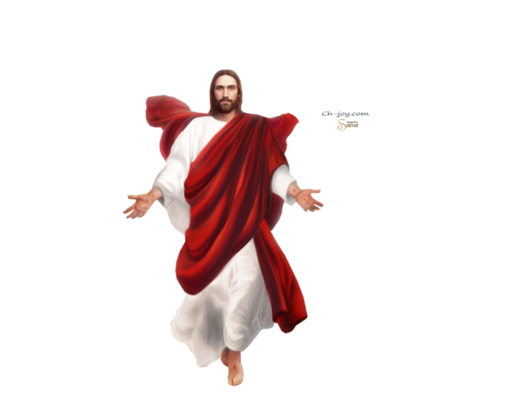

**Discussion Questions:**

***Q: Why is it important to know our foundation here at Harvest?***

***Q: What are your thoughts on the consequences we see from Adam and Eve’s disobedience?***

***Q: We see from the role of Satan in the fall that he uses the elements of surprise, disguise & deception. How does he still use these elements to trip us up today?***

***Q: Satan will try to get us to question God. To question if what God says is true, to question if God is really good. What are some healthy responses to the questions we may have?***

***Q: Satan tries to pervert the good things that God has created; he attempts to pervert the good desires we have. Satan wants us to fulfill those desires apart from God. What can we do to prevent good desires from become destructive ones?***

***Q: Pastor Dale showed us through scripture, how to overcome our fallen nature:***

***Confess your need to God for deliverance, Accept God’s grace & forgiveness, live a life committed to the Lordship of Jesus Christ, and identify the areas your are tempted and fulfill those areas with God’s plan of fulfillment.***

***Which one of these areas do you need to work on? (Personal Reflection)***

***How can you help others that need help in these areas?***

