**January 2021 Foundations Series**

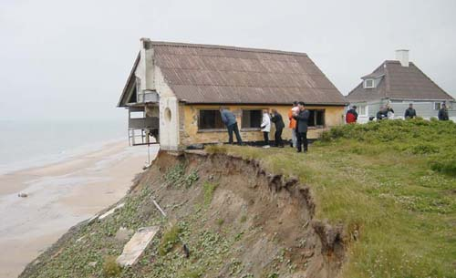

***The Need for Foundation***

**Week 1, January 10th**

**There will be three (3) bible truths to be taught within our church this month:**

**1. The Fall of Man**

**2. The Salvation of Man**

**3. Sanctification**

***This week…we want to help empower the followers of Christ at Harvest by talking about the need for:***

**F O U N D A T I O N.**

* **Without a foundation things become shaky and questionable.**
* **Before a home is built the foundation needs to be poured.**
* *The contractor will dig out and set the forms in the layout for the home, then begin to pour concrete to form the foundation.*
* *A building is only as sturdy as the foundation it is built upon.*
* **If a foundation is faulty it can create all sorts of issues for the home.**
* *A faulty foundation will produce cracks in the walls, flooring that buckles and even plumbing can be affected by a bad foundation.*
* *The home may look beautiful on the outside but what is underneath will eventually show through.*

**This is the driving thought for our foundation’s series.**

* *We want you to know what we as an Assemblies of God church are built upon.*
* *We want you to know the biblical foundation that we preach, teach, & minister (Christ Jesus Paid it All).*

**So before we begin to look at each of these biblical foundations let’s explore:**

**The Need For A Foundation.**

**Scripture:**

Matthew 7:24-27, “Anyone who listens to my teaching and follows it is wise, like a person who builds a house on solid rock. **25**Though the rain comes in torrents and the floodwaters rise and the winds beat against that house, it won’t collapse because it is built on bedrock. **26**But anyone who hears my teaching and doesn’t obey it is foolish, like a person who builds a house on sand. **27**When the rains and floods come and the winds beat against that house, it will collapse with a mighty crash.”

**Scripture Insight:**

* **This passage is a part of Jesus’ Sermon on the Mount.**
* **Jesus shows us two types of builders, a wise builder and a foolish builder.**
* *A wise builder is one who hears and obeys.*
* *A foolish builder is one who hears but doesn’t obey.*
* **When the wise builder listens and obeys he builds his house on solid foundation.**
* **When the foolish builder listens but doesn’t obey he builds on an unstable foundation.**

**The storm came down on both houses…but only the house built on the rock stood firm.**

**A solid foundation comes from not only hearing the word of God but putting it into practice.**

*James 1:22, “But don’t just listen to God’s word. You must do what it says. Otherwise, you are only fooling yourselves.”*

***Many people hear the word of God but not everyone puts it into practice. They build a good-looking house but not a sturdy one.***

***The person coming into the golf course club house might have the fancy/right clothes on, but they don’t practice enough to be called an average or good golfer. It is shown in their actual play.***

***I don’t want to get into a raft to go white water rafting with a guy who does not know the river and its course.***

***KNOW The ONE WHO CAN TAKE YOU THROUGH THE STORMS OF LIFE.***

***Storms in our lives will come in many different forms. Just because we build a solid house it doesn’t mean we won’t face storms. We build a solid foundation to withstand the storms.***

**We need to have confidence in the foundation our lives are built upon.**

**The 16 Fundamental Truths of the Assemblies of God are non-negotiable tenets of faith that all Assemblies of God churches adhere to. Four of these, Salvation, the Baptism in the Holy Spirit, Divine Healing, and the Second Coming of Christ are considered Cardinal Doctrines which are essential to the church's core mission of reaching the world for Christ.**

**Discussion Questions:**

**Q: Have you ever experienced foundation issues with your home?**

**Q: What problems can arise from foundation issues with a home?**

**Q: What problems can arise from spiritual foundation issues?**

**Q: What does a firm foundation provide?**

**Q: What are some things we can do to have a firm spiritual foundation?**

**Q: What are some of the storms that will test our foundation?**

**Q: Why is it important to know our foundation here at Harvest?**

