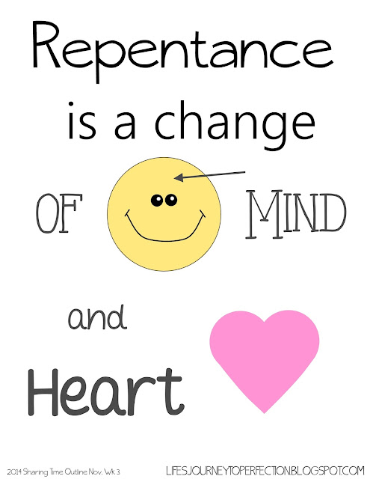

[This Photo](http://www.lifesjourneytoperfection.net/2014/11/lds-sharing-time-november-2014-week-3.html) by Unknown Author is licensed under [CC BY-SA-NC](https://creativecommons.org/licenses/by-nc-sa/3.0/)

**The Biblical Method of Defending Our Hearts**

***In Defense of Our Eyes/Ears/Mouth/Feet/Hands and Mind***

[***Ephesians 5:1-21***](https://www.sermoncentral.com/sermons/scripture/sermons-on-ephesians-5-1-21?keyword=Ephesians+5%3A1-21)***, “****Follow God’s example, therefore, as dearly loved children****2****and walk in the way of love, just as Christ loved us and gave himself up for us as a fragrant offering and sacrifice to God.* ***3****But among you there must not be even a hint of sexual immorality, or of any kind of impurity, or of greed, because these are improper for God’s holy people.****4****Nor should there be obscenity, foolish talk or coarse joking, which are out of place, but rather thanksgiving.****5****For of this you can be sure: No immoral, impure or greedy person—such a person is an idolater—has any inheritance in the kingdom of Christ and of God.[*[*a*](https://www.biblegateway.com/passage/?search=Ephesians+5%3A1-21&version=NIV#fen-NIV-29310a)*]****6****Let no one deceive you with empty words, for because of such things God’s wrath comes on those who are disobedient.****7****Therefore do not be partners with them.* ***8****For you were once darkness, but now you are light in the Lord. Live as children of light****9****(for the fruit of the light consists in all goodness, righteousness and truth)****10****and find out what pleases the Lord.****11****Have nothing to do with the fruitless deeds of darkness, but rather expose them.****12****It is shameful even to mention what the disobedient do in secret.****13****But everything exposed by the light becomes visible—and everything that is illuminated becomes a light.****14****This is why it is said: “Wake up, sleeper, rise from the dead, and Christ will shine on you.”* ***15****Be very careful, then, how you live—not as unwise but as wise,****16****making the most of every opportunity, because the days are evil.****17****Therefore do not be foolish, but understand what the Lord’s will is.****18****Do not get drunk on wine, which leads to debauchery. Instead, be filled with the Spirit,****19****speaking to one another with psalms, hymns, and songs from the Spirit. Sing and make music from your heart to the Lord,****20****always giving thanks to God the Father for everything, in the name of our Lord Jesus Christ. 21Submit to one another out of reverence for Christ.”*

**A simple Children’s song has a powerful Biblical foundation in Ephesians 5, and helps to get us to see what God wants from us, and why.**

**Top of Form**

**Bottom of Form**

**Oh, be careful little eyes, what you see, (repeat). For the Father up above, is looking down in love. Oh be careful little eyes what you see.**

**Oh, be careful little mouth, what you say, (repeat). For the Father up above, is looking down in love. Oh be careful little mouth what you say.**

**Oh, be careful little hands, what you touch (repeat); For the Father up above, is looking down in love. Oh, be careful little hands what you touch.**

**Oh, be careful little mind what you think (repeat); For the Father up above, is looking down in love, Oh be careful little mind, what you think.**

**In the 1950s, the conventional wisdom of the day was that crime was caused by a person’s environment (how they were raised, where they were raised, how poor they were, if they were mistreated, etc.)**

**A psychologist by the name of Stanton Samenow, and a psychiatrist named Samuel Yochelson, believed that very philosophy but there had never been a scientific study to confirm it, so they began a 17-year study involving thousands of hours of clinical testing of 250 inmates in Washington D.C. to prove it.**

**To their astonishment, they discovered that: The cause of crime cannot be traced to environment, poverty, or oppression of criminals. Instead…Crime is the result of individuals making, as they put it, wrong moral choices.**

**In 1977 they wrote a book where they documented their research (The Criminal Personality), and they concluded that the answer to crime is a “_____________ of the wrong-doer to a more responsible lifestyle.” (Christianity Today, August 16, 1993, p. 30)**

**So, in other words, the solution to crime is:**

* **Be careful little eyes what you see.**
* **Be careful little mouth what you say.**
* **Be careful little hands what you do, and**
* **Be careful little mind what you think.**

**BE CAREFUL! That’s essentially what Paul is telling us here in Ephesians 5. “Be VERY careful… how you _______” Ephesians 5:15, “*Be very careful, then, how you live—not as unwise but as wise,…”***

**Be careful what you see… what you say… what you do… what you think. Don’t live as unwise people… but as wise, born-again believers…and alert to the devil’s schemes. Make the most of every opportunity, because the days are evil.**

**Paul goes on to say that: “…God’s wrath comes on those who are disobedient. Therefore do not be ___________ with them.” (Ephesians 5:6-7) Have nothing to do with the fruitless deeds of darkness….” (Ephesians 5:11)**

**IN FACT “… it is shameful even to mention what the disobedient do in secret.” (Eph. 5:12)**

**Well, what are these folks doing, that we ought not to do?**

**Wait a minute…The Bible says, “We are not to even mention what the disobedient do in secret.”**

**The Questions are now before us… Are we to go to the places where evil takes place and share the plan of salvation?**

*Psalm 1:1, “Oh, the joys of those who do not follow the advice of the wicked, or stand around with sinners, or join in with mockers.”*

*Paul warns us, "Do not be deceived: 'Bad company corrupts good morals'" (*[*1 Cor. 15:33*](http://biblia.com/bible/nasb95/1%20Cor.%2015.33)*).*

**Let’s look first at Ephesians 5:4 “Nor should there be obscenity, foolish talk or coarse joking, which are out of place, but rather thanksgiving.”**

**Be careful little mouth what you say.**

**Jesus said, in Matthew 12:35-36, “The good man brings good things out of the good stored up in him, and the evil man brings evil things out of the evil stored up in him. But I tell you that men will have to give account on the day of judgment for every CARELESS WORD they have spoken.”**

|  |
| --- |
| **The moral of this story and this teaching:**  **Be ____________, Like David: *David’s commitment was, "I will set no wicked thing before mine eyes" (***[***Ps. 101:3***](http://biblia.com/bible/nasb95/Ps.%20101.3)***).***  **All Christians should make the same commitment.**  ***It's not possible for us to avoid all the evil that is in the world. But we can avoid evil in many respects. Choose what you watch, see, hear, and touch.***  **“Oh, be careful mind what you think!!”**  **Even if you are unaware of it, you are using your mind every minute of your day.**  **Here is a list of facts about how our minds work:**   * *On an average, it takes about ___ days to form a habit.* * *Closing your eyes helps you remember things.* * *You are not one person, but three – the one you think you are; the one others think you are; the one you _________ are.* * *Close friends and family are the most important source of a child’s happiness.* * *People who practice gratitude are more likely to be happy. Hence, writing down a list of things that you are grateful for each day can really cheer you up and induce a lot of positivity in your everyday life. EKLeader.com*   **Our brain takes in data that we see, hear, touch (feel), smell. Data in—Data out!**  ***Watch out! Which is better? Holding data in your brain and not sending or doing (acting out) the data…or, letting the data or that which we see, hear, and touch acted out.***  [*Romans 13:14*](https://www.biblegateway.com/passage/?search=Romans%2013%3A14&version=NIV)*, “Rather, clothe yourselves with the Lord Jesus Christ, and do not****think****about how to gratify the desires of the flesh.”*  [*1 Corinthians 14:20*](https://www.biblegateway.com/passage/?search=1%20Corinthians%2014%3A20&version=NIV)*, “Brothers and sisters, stop****think****ing like children. In regard to evil be infants, but in your****think****ing be adults.”*  [*Galatians 6:3*](https://www.biblegateway.com/passage/?search=Galatians%206%3A3&version=NIV)*, “If anyone****think****s they are something when they are not, they deceive themselves.”*  [*2 Peter 3:1*](https://www.biblegateway.com/passage/?search=2%20Peter%203%3A1&version=NIV)*, “Dear friends, this is now my second letter to you. I have written both of them as reminders to stimulate you to wholesome****think****ing.”*  [*Romans 8:5-6*](https://www.biblegateway.com/passage/?search=Romans%208%3A5-6&version=NIV)*, “Those who live according to the flesh have their****mind****s set on what the flesh desires; but those who live in accordance with the Spirit have their****mind****s set on what the Spirit desires. The****mind****governed by the flesh is death, but the****mind****governed by the Spirit is life and peace.”*  **Summary:**  **We are to use our wonderful created bodies, souls, and minds wisely and healthy…___________ healthy. Guard yourself…and be careful how we use God’s gifts to each of us!**  [*Philippians 4:8*](https://www.biblegateway.com/passage/?search=Philippians%204%3A8&version=NIV)*, “Finally, brothers and sisters, whatever is true, whatever is noble, whatever is right, whatever is pure, whatever is lovely, whatever is admirable—if anything is excellent or praiseworthy—****think****about such****things****.”*  **Eye** |

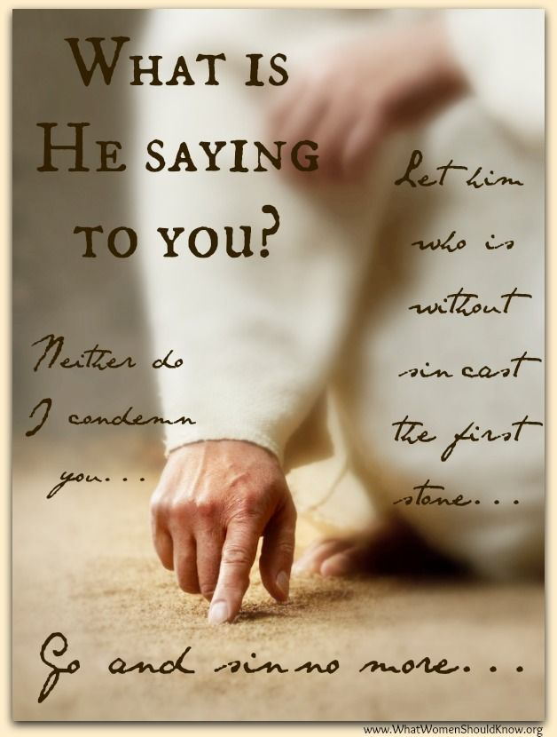

[This Photo](http://ijboudreaux.com/) by Unknown Author is licensed under [CC BY-ND](https://creativecommons.org/licenses/by-nd/3.0/)