Session 1: David
There are some things we can dream about…but they probably will never happen!
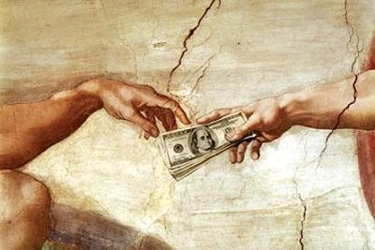
What do you think you could accomplish if you were a King of a country…or President of the United States?
What do you think you can accomplish by being a mom or dad that loves the Lord?
As a parent, what is the most important thing we can teach our children?
“Trust in the Lord with all your heart…and lean not on your own understanding”(Proverbs 3:5).
“God is our refuge and strength, an everpresent help in trouble” (Psalm 46:1).
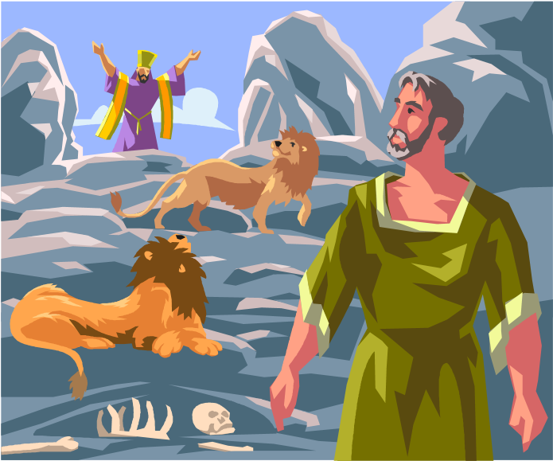
David…A Man After God’s Heart!
Lesson Sessions:
- David Becomes King, 2 Samuel 5:1-5; Psalm 37
- David is Merciful to Mephibosheth, 2 Samuel 9:1-13
- God Forgives David, 2 Samuel 11:1—12:10; Psalm 51:1-12
A Synopsis of David’s Life….And The Hardships In His Life on the Road to Become King!
- David lived as an outlaw…because the King of Israel, Saul, had turned from the Lord and sought to kill David because he was a threat to Saul’s kingdom and throne.
- King Saul was wounded in battle and took his own life in lieu of being captured. Three of Saul’s sons died in battle, including Jonathan (David’s closest friend besides the Lord).
- Door open for David to become King.
- No rejoicing from David….He mourned for the king and the people (respect for authority, respect for God’s sovereignty, the political position of Saul, and for his friend, Jonathan) • David wrote a song in honor of Saul and Saul’s son, Jonathan
- David made King of Judah.
- David later became King of both, Judah and Israel…and united the two kingdoms.
- David was 37 when he became king over all Israel.
- He was anointed to succeed Saul many years earlier as a teenager.
- David’s dynasty reigned in Judah for more than 400 years.
- After a long and patient wait, David had become king and he led Israel to great prosperity…defeating the Philistines, and expanding the boundaries of Israel.
- Israel and Judah divides again….over greed and blasphemy….having other gods.
- David was not perfect…but he relied on God.
- God rewarded David and Israel with prosperity.
- David wrote Psalm 37…describing his trust is God even while being surrounded by enemies.
What Does It Mean to “Rely on God”? Read 2 Samuel 5:1-5
Life’s pressures—How do we handle them?
What is your hardest challenge in life right now?
Why?
How do you respond when you face great stress?
Why?
What have you learned from difficulties you’ve faced?
Why does God allow us to face difficulties?
If you were to write your epitaph for your life…What would you want it to be?
David’s Theme of Trust….
Can It Be Our Theme?
“Delight yourself in the ways of the Lord and He will give you the desires of your heart” (Psalm 37:4)
- Relying on God….is trusting the Lord in all circumstances of life.
- Relying on God….is accepting the sovereignty of God…and believing His promises.
- Relying on God…is making Jesus the King of Your Life….and training your family to do likewise.

Take the Word of God Home…and into the Hearts of your family!
Scripture to Remember:
“God is our refuge and strength, an everpresent help in trouble” (Psalm 46:1).


