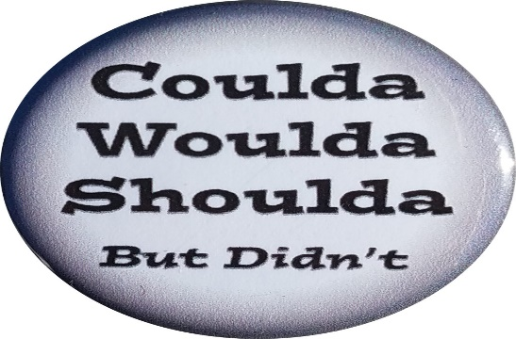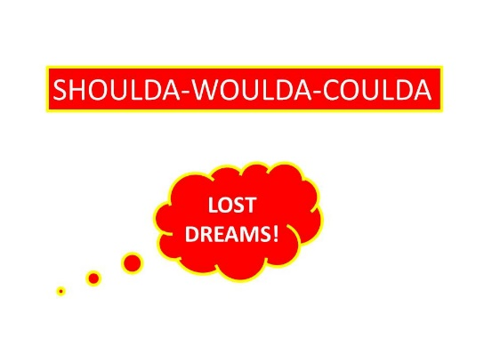

**Biblical Survey of Our Lives**

***The “-Coulda-Woulda-Shoulda” Bible Lesson***

***By Gerald E. Cumby***

**For most people, there seems to be a clear distinction between what actually happened and what they *wished* would have happened in a given situation.**

*Do you feel that this is true in most peoples’ assumption of life complications and situations as they deal with life in general?*

**Sometimes, people realize a number of options they could have or should have taken instead of the action they actually took.**

**This feeling of regret or second-guessing is summed up in the expression *woulda, coulda, shoulda.***

For instance, A man who handed over his car to a thief who was threatening him might agonize over whether or not it *would* have been smarter to run and flee the scene, *could* have attacked the thief, or *should* have refused to comply.

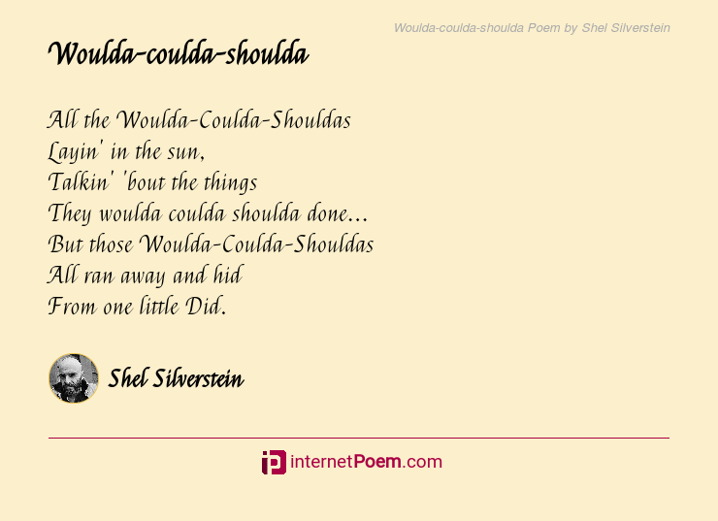

**What does "Woulda Coulda Shoulda" Mean?**

* [**"Woulda, coulda, shoulda" refers to the regret some feel over an action not taken.**](https://www.infobloom.com/what-does-woulda-coulda-shoulda-mean.htm#imagePopup)

The expression is actually an informal rendering of three conditions: would have, could have, and should have. These are considered *subjunctive moods*, because they imply possible or theoretical conditions, otherwise known as wishful thinking.

I.e. The owner of the car in the previous scenario *coulda* run away, *shoulda* attacked the thief… or *woulda* talked to the thief out of doing such an act that potentially might land him in prison…but none of these conditions actually happened.

*Note:* Woulda*,*coulda*, and*shoulda*are not just the constituent parts of an expression you use when you realize that you didn't do something you might've (mighta?) done. All three words are colloquialisms, and take their initial verb and add a final “*A”*as a shortening of the word “*have*.” None of them are what would be described as standard English, but, as is so often the case with such words, they have been around for a lot longer than any of the people who might complain about their use.*

*\*Sort of like a Texan saying, “Y’all sat your backside down…rat now!*

* [**"Woulda, coulda, shoulda" often expresses feelings of frustration and fear.**](https://www.infobloom.com/what-does-woulda-coulda-shoulda-mean.htm#imagePopup)

"Woulda, coulda, shoulda" circumstances are more common than many people would like to admit. For instance:

* A nervous adolescent boy asking a girl for a date may get tongue-tied on the phone, but later realize what he might have asked her during the conversation.
* An employee explaining to his boss why he missed an important date and time on a project may offer up an ineffective response for why he procrastinated and did not fulfill his appointed response time for the project.
* A man on his death bed refuses to accept the fact that Jesus desires to take on the man’s sin (all past sins) and give him eternal life. He dies without accepting the offer available to him. In hell, he lifts up his eyes and states, “I coulda asked for forgiveness and repented of my sin…and I shoulda done it—for this is place I don’t want anyone to be for eternity…I woulda done it if I knew what was in store for me.”

**For those seeking concrete answers, a "woulda coulda shoulda" reply can be translated as a defensive dodge…or, a tragic, major, catastrophic mistake leaving horrible consequences.**

***Luke 9:62****– Jesus said to him, “No one who puts his hand to the plow and looks back is fit for the kingdom of God.”*

Throughout God’s Word, God tells us to look forward and not backward…to move past our mistakes and shortcomings…to give up on beating ourselves with regrets and sorrows…and accept the fact that we can use our mistakes and our guilt(s) and use them to help ourselves and others to live life looking ahead to the future. We, as Christians are supposed to be free of guilt from our past failures. We are to be the person God has planned for us to be. Sometimes our failures help us to be winners. In fact, most of the time this is how we grow…accepting our failures as rocks and chasms to help us climb to the top.

Bible examples: Lot’s wife (looking back), Paul (I’m the worst of sinners…but I am stretching toward the mark of the high-calling of God), Moses killing a man and yet understanding that God will still use him to move God’s chosen people to victory.

**It’s time to deal with the “shoulda’s, woulda’s, and coulda’s!”**

**Confession time: I make major mistakes, resulting in my being an expert in the “shoulda’s, woulda’s, and coulda’s.”**

*One temptation we face is focusing on our regrets, failures, disappointments, guilt, and shame. During our prayer time, we might say, “God, I shoulda done this. If I woulda only done this instead. If I coulda gone back and changed things. If I coulda somehow made this right.”  If we don’t say it at times…we undoubtedly think it!*

***While every bit of this may be true, and it is essential to acknowledge this to God, it’s more important to keep our eyes on God’s next step for us instead of looking back.***

*When driving a car or riding a bicycle, we focus on where we’re going instead of where we’ve been. Like the woman caught in the act of adultery, Jesus knew where she’d been and what she’d done, but he also saw what she could become.  And…we can grow through the troubles and mistakes to help us to be all that God wants us to be. We can look forward from a loss (mistake) to the challenge of being a winner in the end.*

***Yes, we need to present the shoulda’s, woulda’s, and coulda’s to God, but then let go of them, and seek God’s shall’s, will’s, and can’s. While the devil tempts us to focus on the past, Jesus encourages us to keep our eyes on Christ, following him into the future.***

*When my dad died (killed in a bridge construction accident), I remember well the intense guilt I had in the months that followed.  Though his death didn’t fit into one of the categories known for guilt, that didn’t stop me from feeling guilty…and even shame. I had regrets and, at times, I still feel those “Shoulda, Coulda, Wouldas” creeping into my repertoire of thinking!*

**Now… How do we cope with two powerful emotions–guilt and shame?**

**Until we discover that God has provided a way to overcome these gut responses, we have some internalized ways for “handling” a crisis:**

**SHOULDA.** *We point that accusing finger at ourselves and say, “You shoulda prayed with your mom before she died.” “You shoulda said you were sorry before dad had the accident.”  “I could have told our daughter to go to the doctor because she was looking pale and not herself.” (We won’t go there!!)*

**COULDA.** *Then we tell ourselves what we could have done differently. “You coulda actually stayed in the room with mom all night long and let her listen to me as I was telling her how wonderful of a mother she was.” I could have told dad how much his love for his family was exhibited throughout his life.” I could have…I could have…I could have!*

**WOULDA.** *Then we lighten the load of guilt and shame (or so we think) by saying what we would have done under other circumstances: “I woulda prayed more and with the loved one if I ‘woulda’ known what was coming in the near future.*

***Talking to yourself can be helpful if you are healthy and self-aware. If you are unhealthy emotionally and don’t have an accurate view of reality, dialoguing with self will put off taking important steps to walk out of your past into your future***. Damaging emotions like self-incrimination have the opposite effect of blaming others rather than taking appropriate responsibility for your attitudes and actions.

***Shoulda, coulda, woulda describe people who are safer with their past than their future.***

***Many people vote for regret than repentance***. Something may need to change. I can’t simply cry about the person who misrepresented me, scorned me, told me I’d be better off going to a Trade School in lieu of College. Rather than changing, we excuse ourselves with inferior emotions that attach blame. The woulda can release us from the coulda. The shoulda says that we are aware of what we have done, but it stops short of repentance that invites the mercy of God and contributes to change. It freezes us in illegitimate self-talk, keeping us from a divine make-over. The coulda shows our “good intentions.” The woulda says that we might have done things positively under different circumstances. The verdict: guilty as charged***. The verdict and truth: Shoulda, coulda, and woulda are lame excuses.***

**What is a better response?**

The cross of Jesus Christ…God’s provision for our bad judgment, our stupid mistakes, our deliberate sin. However, we must come with brokenness, not excuses. Don’t attempt to lighten the load so “it’s not that bad.” In actuality, it is worse. Otherwise, Christ would not have had to die. He did not die for an inaccurate judgment but for wrong decisions, an immature heart, a loveless response.

***The cross enables us to truly repent rather than “playing it safe” and holding back.***

***What should we say to ourselves…we who put repentance on hold?***

***“Jesus, help me to do the things I know to do according to your Word and not 2nd guess myself with doubts and wavering faith.***

***THEREFORE:***

***“Goodbye…shoulda, coulda, woulda! Hello…shall’s, will’s, and can’s.”***

***Note: Much of the thoughts for this lesson was taken from a sermon/blog by Paul Anderson, Dare to Dream website. Paul blogs several times per month and his thoughts and powerful truths can only come from a praying man who desires to challenge his readers to a growing knowledge of Christ.***

***I placed some of my own stories and additional information to a wonderful blog by this mature and godly man being used by God.***

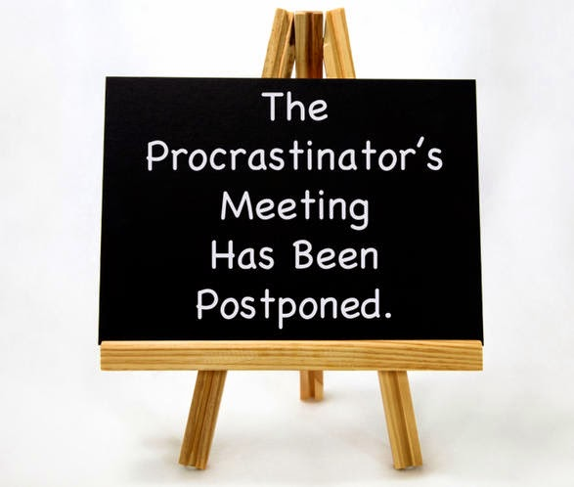

***LEARN TO DO IT TODAY AND NOT WAIT UNTIL TOMORROW!***