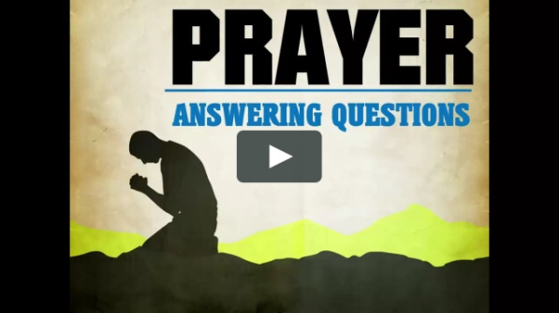

***Questions and Answers for the Church of Thessalonica***

***What, Why, Where and When?***

***Most all information can be gathered on any subject when the answers are accurately given on those four questions.***

***Just think…What are you doing? What was the purpose of the story? What did you do to be successful in life? What actions did you take to stop the atrocities? What was the most important decision you had in life?***

***Why did you go there in the first place? Why did he think you would be agreeable to such terms? Why did you say “Yes” when it would be easier to say “No”? Why was it important to stay faithful to your spouse? Why do you think you will go to heaven?***

***Where did you go? Where did you hear about such a terrible thing? Where were you when I needed you? Where are the important papers that we need to address the situation? Where are you going after you die?***

***When are you going to stop this cycle of sinful practices? When did you feel you were over this horrifying experience? When is the best time to come over and help you to complete the project? When do you think you will be ready to accept Jesus?***

**Prayer is a complex phenomenon and there are times in life when God seems not to answer our prayers involving very important issues such as a death or an accident of a loved one, a struggle, or a painful situation. The stories of people whose prayers were answered are not meant to simplify, wrap into a tidy package or define how God works or His nature, or explain why some people regularly receive answers to prayers, while others do not, though these persons may be equally as faithful to God. In some prayers, the answers are instantaneous, but as we know, some answers to prayer may come slowly and quietly after many years. Why will God answer a prayer for a lost item, but seem quiet in the face of tragedy?  Such is the mystery of God.**

**But God has many things He wants to teach us and has His reasons for doing what He does. There are countless times that God does answer our prayers, yet we are blind to recognize them. And though it may seem that God is against us or has abandoned us, we may never understand what it all means until it is revealed to us in the future.**

**So though we wish God would answer all of our prayers, all of the time, we have come to understand that though we don’t get what we want most of the time, we trust in God’s infinite wisdom and thank Him for His faithfulness to us and hope to one day understand the whys for our existence here on earth when we do see Him.**

www.crosswalk.com

***2 Thessalonians 3:1-2, “Finally, brethren, pray for us, that the word of the Lord may run swiftly and be glorified, just as it is with you, and that we may be delivered from unreasonable and wicked men; for not all have faith.”***

* **Paul constantly asked other Christians to pray for him** ([*Romans 15:30*](https://www.blueletterbible.org/search/preSearch.cfm?Criteria=Romans+15.30&t=NKJV)*,* [*2 Corinthians 1:11*](https://www.blueletterbible.org/search/preSearch.cfm?Criteria=2Corinthians+1.11&t=NKJV)*,* [*Ephesians 6:18-19*](https://www.blueletterbible.org/search/preSearch.cfm?Criteria=Ephesians+6.18-19&t=NKJV)*,* [*Philippians 1:19*](https://www.blueletterbible.org/search/preSearch.cfm?Criteria=Philippians+1.19&t=NKJV)*,* [*Colossians 4:3*](https://www.blueletterbible.org/search/preSearch.cfm?Criteria=Colossians+4.3&t=NKJV)*,* [*1 Thessalonians 5:25*](https://www.blueletterbible.org/search/preSearch.cfm?Criteria=1Thessalonians+5.25&t=NKJV)*, and* [*Philemon 1:22*](https://www.blueletterbible.org/search/preSearch.cfm?Criteria=Philemon+1.22&t=NKJV)*).*

**Paul knew that the success of his ministry in some measure depended on the prayers of God’s people.**

**If we could see into the heavenlies, we would see millions of prayers going up to the throne room. If we did not have prayer as the main resource for our existence as well as others, we would not understand faith, forgiveness, or repentance. We can usually tell how strong our faith is by our prayer life in praying for others.**

**Praying for others is really building up our faith to be strong in times of the storms that come in our life. When we seek help for others, we are asking God to help us be an overcomer in the trials and tribulations of life.**

* “**That the word of the Lord may run swiftly and be glorified”**:
* *Paul asked for prayer so that the Word can* ***run*** *freely, without any hindrance. Paul’s prayer request makes us wonder how often the work of God’s Word is hindered by our prayerlessness.*
* *God has promised that His Word would be free and perform its work: “It shall not return to Me void, but it shall accomplish what I please, and prosper in the thing for which I sent it (*[*Isaiah 55:11*](https://www.blueletterbible.org/search/preSearch.cfm?Criteria=Isaiah+55.11&t=NKJV)*).”*
* *But as with many of God’s promises, we are expected to take this promise in faith, and in prayer, to ask God to perform that faith to full fruition* ***FOR HIS GLORY****.*
* “**That we may be delivered from unreasonable and wicked men**:”

**There were those who wanted to hinder the work of the gospel. Paul wanted God to either:**

* *Deliver him from such men, or*
* *Change them into reasonable and godly men.*

***2 Thessalonians 3:3-5, “But the Lord is faithful, who will establish you and guard you from the evil one. And we have confidence in the Lord concerning you, both that you do and will do the things we command you. Now may the Lord direct your hearts into the love of God and into the patience of Christ.”***

* **But the Lord is faithful**:
* *Even if not all men have faith, the* ***Lord is faithful****.*
* *This was the basis of Paul’s confidence in God’s ability to* ***establish*** *and* ***guard*** *us from the* ***evil one****.*

God promised to keep Satan on a leash. He will not allow any temptation to become too great for us ([1 Corinthians 10:13](https://www.blueletterbible.org/search/preSearch.cfm?Criteria=1Corinthians+10.13&t=NKJV)), and will not allow Satan to do whatever he wants with us ([Luke 22:31-32](https://www.blueletterbible.org/search/preSearch.cfm?Criteria=Luke+22.31-32&t=NKJV)).

* **And we have confidence in the Lord that you do and will do the things we command you**:
* *Paul was also confident (****in the Lord****) regarding the Thessalonians themselves, that they would follow through and be obedient to God’s Word.*
* *This shows that God’s work of establishing and guarding us is done, in part, through His appeal to our will in obeying His Word.*
* *God doesn’t just pour spiritual maturity and stability into us. He works it in us through our cooperation with His will.*
* *The Key is to have a balanced spiritual life through reading God’s Word, meditating on God’s Word, and doing God’s Word.*
* **Now may the Lord direct your hearts**:
* Paul wisely prayed for both **love** and **patience** (endurance) for the Thessalonian Christians.
* These two qualities are essential for the kind of spiritual stability and strength of the Thessalonians…and us (believers today).

**Love and Patience (Endurance)**

***“With love and patience, nothing is impossible.”***

***“Patience with others is love; Patience with self is hope; Patience with God is faith.”***

***“Patience is not sitting and waiting, it is foreseeing. It is looking at the thorn and seeing the rose. It is looking at the night and seeing the day.”***

***“Good things come to those who believe, better things come to those who wait, and the best things come to those who don’t give up.”***

**NEXT WEEK: Instructions for the strength and purity of the church.**

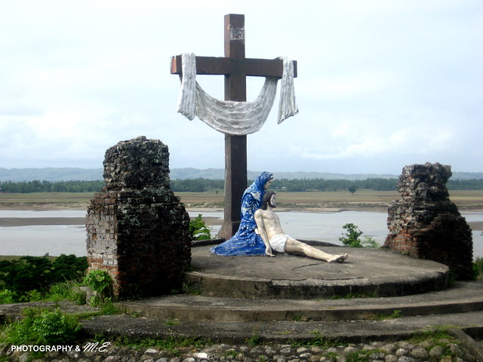

**“**[**God answers prayer in three ways: yes, no, and wait awhile.**](https://www.azquotes.com/quote/1059129?ref=god-answers-prayers)**”**

[**Norman Vincent Peale**](https://www.azquotes.com/author/11448-Norman_Vincent_Peale)