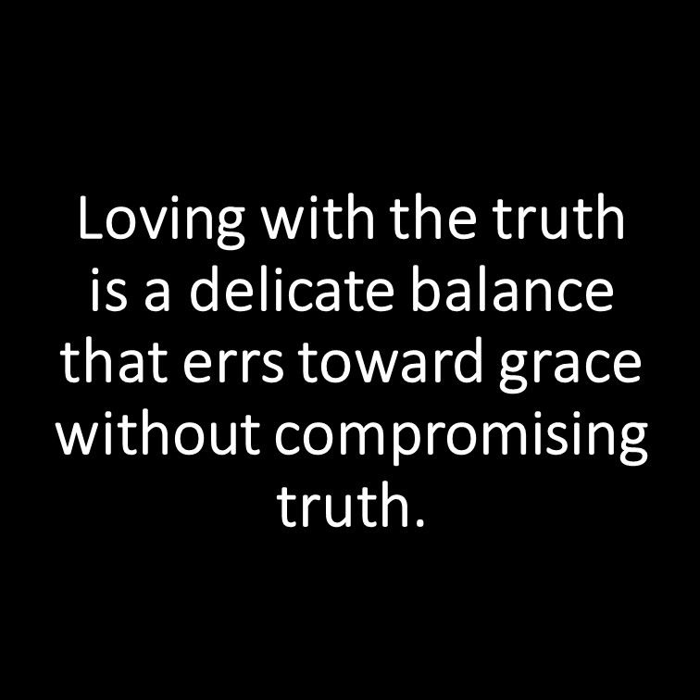

[This Photo](https://epitemnein-epitomic.blogspot.com/2015/09/loving-with-truth.html) by Unknown Author is licensed under [CC BY-NC-ND](https://creativecommons.org/licenses/by-nc-nd/3.0/)

**Love and Truth Help Balance Out the Christian Lifestyle!**

**Lesson 2, 2nd John**

**Gerald Cumby, Teacher**

***To be or not to be—that is the question?***

***To love or not love—that is the question?***

***To listen to a lie or heed to the lie—that is the question?***

*The word “love” appears 2,146 times in Shakespeare’s collected works (including a handful of “loves” and “loved”). That is a whole lot of love!! Truth = Mentioned 333 times in the Bible.*

***John spoke of love and truth in his letters to the churches. Paul taught similar subjects and truths (faith, hope, and love) to the church attending family members.***

***Both John and Paul tried to protect these new converts from:***

1. ***the “vultures” preying on the weak,***
2. ***the false teachers from the lies and corruption of God’s Holy Word.***
3. ***The “Name it and claim it” (money grabbing) fast-talking salesmen who were “here today and gone tomorrow.”***

***Both John and Paul were wise counselors who spent much of their time cleaning up the stench and trash coming from the mouths of these “shysters” who tried and, in many cases succeeded, in leading the new converts away from the truth. “Devil dealing/demonic promoting” distortion of the truth was what they were selling to the church members at Ephesus and other surrounding cities.***

***2 John 1-3, “1The elder, to the lady chosen by God and to her children, whom I love in the truth—and not I only, but also all who know the truth— because of the truth, which lives in us and will be with us forever: Grace, mercy and peace from God the Father and from Jesus Christ, the Father’s Son, will be with us in truth and love.”***

***2 John 4 - 6, “It has given me great joy to find some of your children walking in the truth, just as the father commanded us. And now, dear lady, I am not writing you a new command but one we have had from the beginning. I ask that we love one another. And this is love: that we walk in obedience to his commands. As you have heard from the beginning, his command is that you walk in love.”***

***2 John 7-9, “I say this because many deceivers, who do not acknowledge Jesus Christ as coming in the flesh, have gone out into the world. Any such person is the deceiver and the antichrist. Watch out that you do not lose what wehave worked for, but that you may be rewarded fully. Anyone who runs ahead and does not continue in the teaching of Christ does not have God; whoever continues in the teaching has both the Father and the Son.”***

***2 John 10-13, “If anyone comes to you and does not bring this teaching, do not take them into your house or welcome them. Anyone who welcomes them shares in their wicked work. I have much to write to you, but I do not want to use paper and ink. Instead, I hope to visit you and talk with you face to face, so that our joy may be complete. The children of your sister, who is chosen by God, send the greetings.”***

**In the letters from John, he warns his people that the wrong kind of wandering prophets might come claiming knowledge and wisdom of God…seeking money and hospitality.**

***John was entirely justified in warning his people and saying that they must on no account receive these imposters and vultures.***

**In this passage, love and truth are inseparably connected**.

It is in the truth that the elder loves the elect lady. It is because of the truth that he loves and writes to the church.

**It is the agape love…**

**Agape love:**

* ***Is not passion with its ebb and flow, its flicker and flame. It is not an easy-going sentimentalism…***
* ***It is an undefeatable goodwill…it is the attitude towards others which, no matter what they do, will seek their highest good and will accept all the difficulties, all the problems and all the toil which that search involves.***
* ***It is not easy to acquire or a light thing to put into practice.***

**It is of great significance that John writes in love to warn.**

**Note: John begins his warning with grace….mercy….and peace.**

*He wants them to receive the letter with grace….show mercy as Jesus would show mercy…and heed the warning seeking peace with the brothers. He was blunt, but caring. Warned with gentleness…but direct…And,*

***He was specific in getting them to understand that God is the Father…and Jesus is the Son****.*

Jesus warned of the wolves in sheep’s clothing…of those whose hearts were out to deceive.

“Ye believe in God, believe in me. I and my Father are One. How the Father thinks, I think!”

**This passage implies that there are some divisions in the church.**

Why do we know that?

The statement… “joy in knowing that SOME of your children are walking in truth.”

**One remedy to any division in the Church….love.**

It is no new remedy and no new commandment…It is the word of Jesus Himself, “I give you a new commandment, that you love one another. Just as I have loved you, you also should love one another. By this everyone will know that you are my disciples, if you have love for one another.” (John 13:4-5)

**As we go on, we shall see that there is another side to this and that there is no soft sentimentality in John’s attitude towards those who were leading people away from the truth.**

**The Closing of a Love Letter to the Church from a Concerned and Compassionate Leader of Christian Ideals**

**The problem…same problem cropping up in every congregation…someone preaching against the incarnation of Jesus…coming actually (truly) in the flesh.**

**John believed and knew from experience that:**

* Jesus was truly born;
* Jesus truly became man;
* Jesus truly suffered, and
* Jesus truly died.

**Martin Luther made the statement about Jesus….**

“He ate, drank, slept, waked; was weary, sorrowful, rejoicing; He wept and he laughed; he knew hunger and thirst and sweat; he talked, he worked, he prayed….so that there was no difference between him and other men….save only this, that He was God, and had no sin.”

**Read Hebrews 1:5-8, “*5****For to which of the angels did God ever say, “You are my Son; today I have become your Father”? Or again, “I will be his Father, and he will be my Son”?* ***6****And again, when God brings his firstborn into the world, he says, “Let all God’s angels worship him.”* ***7****In speaking of the angels he says, “He makes his angels spirits, and his servants flames of fire.”****8****But about the Son he says, “Your throne, O God, will last for ever and ever; a scepter of justice will be the scepter of your kingdom.”*

**John, in verse 8-9, state that these false teachers claim to be DEVELOPING Christianity, discovering** **more truly what it means to advance the Kingdom of God (in their own way of thinking).**

Advance….running ahead, go on ahead,

Translated…. “everyone who goes too far.”

**John insists that they are destroying Christianity and wrecking the foundation which has been laid and on which everything must be built.**

**Who are they? They were claiming to be the progressives, the advanced thinkers, and the people with open and adventurous minds.**

John was an adventurous thinker of the New Testament.

John is not condemning progressive thinking; but he is saying that Jesus Christ must be the measure of all thinking and that whatever is out of touch with Him can never be right.

Jesus himself stated, “I came not to abolish the law, but to fulfill it.”

**Christianity is not a vague, uncontrolled philosophy on the nature of God….it is anchored to the historical figure of Jesus Christ…who is the same yesterday, today and forever. God says, “I change not.”**

**Note: Change is inevitable in our society. However, we…as Progressive Christians (not politically) must choose what is to be changed wisely and constructively. All the changes must be based on holding up the “long-held theme” of keeping Christ in the forefront….and making sure that going against “the establishment” is not always right.**

**Remember….holding up traditions is not wrong. It is when we worship traditions that it is wrong.**

**John saw a clear danger in these false teachers.**

They are to be given no hospitality; and the refusal of hospitality would be the most effective way of stopping their work.

John goes on to say that they are not even to be given a greeting on the street.

**It should be quite clear to the world that the Church has no tolerance for those whose teaching destroys the faith.**

This passage may seem on the face of it to imply an attitude which is the exact opposite of Christian love; but those times dealt with imposters of the truth like we should deal with them…no compromise.

**Remember, we can never compromise with mistaken or false teachers….but we are never free from the obligation of seeking to lead them into the truth.**

**As we close the 2nd Epistle of John, we see that John knew that it was best for him to stop writing or the receiver on the other end could misunderstand or misconstrue the meaning of the letter.**

*In many churches and in many personal relationships, letters have merely succeeded in making a situation worse; for the most carefully written letter can be misinterpreted, when a conversation might have put matters right.*